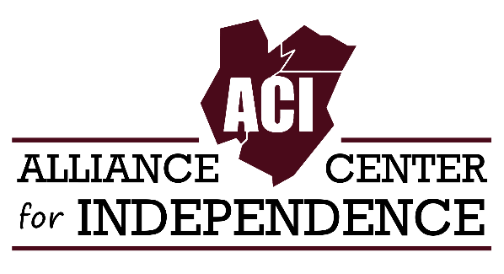
For Immediate Release
Carole Tonks
Executive Director
732-738-4388
ctonks@adacil.org

Join us for ACI’s Family Fun Day this Saturday!
EDISON, NEW JERSEY - The Alliance Center for Independence (ACI) will present Family Fun Day on Saturday, June 25th. The event will take place at 635 Amboy Ave, Edison, NJ, behind St. Paul the Apostle Senior Housing. Rain date: July 9th 2022.
Family Fun Day is open to the public and geared towards people with disabilities and their families.
Free COVID-19 vaccines and booster shots will be provided by the Middlesex County Health Department. St. Peter’s University Hospital in New Brunswick will be on hand to distribute free COVID-19 kits. The event will also feature small games, prizes, ice cream and a food truck.
“The purpose of this event is to highlight the importance of getting vaccinated while providing a fun day for people with disabilities and their families.” says Carole Tonks, Executive Director of ACI.
Participants who receive a vaccine or booster and complete a vaccine survey at the event will receive a free $25 ShopRite gift card and a ticket for free ice cream.
“We know many people in our community have not been vaccinated. We wanted this event to reach those that don’t traditionally seek our services, including individuals with disabilities whose primary language is Spanish.” said Kim Garcia, ACI’s Public Health Program Coordinator and one of the interpreters at the event.
Family Fun Day is made possible through a grant from the Disability Vaccine Access Opportunities Center.
For more information, contact Kim Garcia at 732-738-4388 ex. 123 or kgarcia@adacil.org
About ACI
The Alliance Center for Independence is a non-profit 501(c)(3) organization in Edison, NJ. Founded in 1986, ACI recognizes disability as a natural and beautiful part of human diversity. ACI supports and promotes independent living for people with disabilities in Middlesex, Somerset, and Union counties. Learn more about ACI by visiting our website: adacil.org

