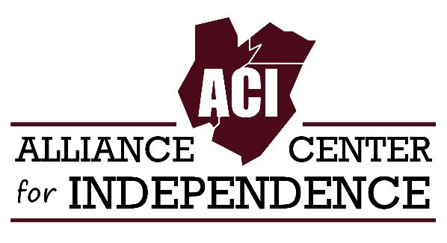
FOR IMMEDIATE RELEASE
CONTACT: Carole Tonks, Executive Director, Alliance Center for Independence
Phone: (732) 738-4388
Email: ctonks@adacil.org
Website: www.adacil.org

THE 8th ANNUAL NEW JERSEY DISABILITY PRIDE PARADE & CELEBRATION SET FOR OCTOBER 5th IN TRENTON, NJ

More than 800 people with disabilities, supporters, friends and organizations representing a wide variety of services throughout NJ will converge on West Lafayette Street in downtown Trenton for the 8th Annual NJ Disability Pride Parade and Celebration.

The free event is a grassroots effort organized and hosted by the Alliance Center for Independence (ACI). ACI is a 501(c)(3) Center for Independent Living, a community-based, grassroots organization that supports and promotes independent living for people with disabilities in Middlesex, Union and Somerset counties.

"This is the one event in New Jersey that the disabled community can get together and have a day to celebrate pride in each other," says Carole Tonks, Executive Director of the Alliance Center for Independence, and chief organizer of the event.

The purpose of the NJ Disability Pride Parade is to celebrate pride within the disability community and to promote the belief that disability is a natural and beautiful part of human diversity.

The event will feature a number of disabled artists and entertainers, including Black Cat Habitat, an indie pop-rock band, and Signs of Praise Ministry, a gospel group that sings through the use of sign language. Fan favorites, including recording artist Lachi, folk singer Johnny Crescendo, motivational speaker and radio personality Mark Farrell and singer and pianist Andrew Bainbridge will be returning.

The day kicks off with an address by NJDPP 2018 Parade Marshal Chris Miller, a disability advocate at the State House Annex on West State Street. This will be followed by a parade led by the Mercer County Special Services School District Drum Line to the site of the celebration on West Lafayette Street. There, the Mayor of Trenton, the Honorable Reed Gusciora, will give the official welcoming remarks. Other dignitaries that will be addressing the crowd will be Assemblyman Eric Houghtaling and Assemblywoman Joanne Downey of the 11th legislative district.

Longtime disability and civil rights advocate, Ethan Ellis, will be honored with a lifetime achievement award. MC’ing the event is 2018 Ms. Wheelchair New Jersey, Kathy Ford.
A bubble artist, face painter, hula hooping and Sparkee from the Somerset Patriots will add to the festivities of the day. Register to vote at the REV UP NJ table and get a free t-shirt!

Attendees will also have an opportunity to learn about disability services and programs from 30 exhibitors representing non-profit and for-profit organizations throughout the state.

The event relies solely on sponsorship, exhibitors, donations and in-kind services. Sponsors include, Brownstone Diner and Pancake Factory, PSEG, NJ Division on Disability Services, NJ Council on Developmental Disabilities, Fun Truck’n Mobility, Herrs, Drake Cakes, Pepsico, Frito Lay, J and J Snacks, Coca Cola, Snapple, the NJ Association for Centers of Independent Living, Ester Seals Disability Services, Freehold Buick and GMC, The College of New Jersey, NJ Coalition to Domestic Violence, to name a few.

629 Amboy Ave, Edison, NJ 08837 ● adacil.org ● adacil@adacil.org
732-738-4388 ● Fax: 732-738-4416 ● TTY: 732-735-9644 ● VRS: 732-709-1023

