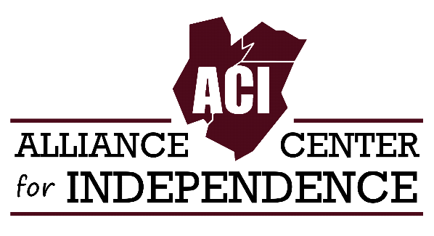
FOR IMMEDIATE RELEASE CONTACT: Luke Koppisch, Deputy Director, Alliance Center for Independence Phone: (732) 738-4388 / E-mail: lkoppisch@adacil.org Website: www.adacil.org

DISABILITY ADVOCATES WILL CONDUCT TRUMP CAMPAIGN CALL-IN DAY ON JULY 14th TO BRING ATTENTION TO 54 MILLION PEOPLE AMERICANS WITH DISABILITIES.

On July 14, the Alliance Center for Independence (ACI) in Edison and REV UP- NJ, will organize a Call-In day to the Trump for President Campaign Headquarters in New York City to demand that Donald Trump address the concerns of 54 million people in the United State with disabilities.

The disability community is outraged that the Trump Campaign has refused to respond to the questionnaire posed to it in January by RespectAbilityUSA, a disability advocacy organization based in Baltimore.. All the major candidates for president on both sides of the aisle were sent the 16- item questionnaire which addressed disability issues and policy. Several candidates responded prior to dropping out of the race including Jeb Bush, Ben Carson, Chris Christie, John Kasich and Bernie Sanders. Hillary Clinton’s response to the question can be viewed on the RespectAbility website. With less than one week before the Republican Convention, the Trump Campaign has yet to respond.

The questionnaire on disability-related issues put together by RespectAbility can be found at http://respectabilityusa.com/pwdsvote-2016-campaign-questionnaire/

"We urge Trump to share his position on education, employment, housing, enforcement of the Americans with Disabilities Act, Social Security and other issues important to us, " says Carole Tonks, Executive Director of ACI and organizer of the Call-In Day. " We refuse to be ignored."

According to Tonks, "People with disabilities and their families represent a major voting bloc. His dismissal of this community should not go unchallenged."

Other disability groups participating in the call in day include: NJ Centers for Independent Living, Liberty Resources in Philadelphia, RespectAbilityUSA, The ADA Legacy Project, and ADAPT of Pennsylvania.

The Call-In Day will take place between 9 and 3 pm. Participants are encouraged to call the Trump's Campaign Headquarters in New York City at 646-736-1779 or email the campaign at policy@donaldtrump.com or send a message through social media. A script and a sample email was developed by ACI.

The Alliance Center for Independence (ACI). ACI is a 501(c) (3) community-based, grassroots organization that supports and promotes independent living for people with disabilities in Middlesex, Union and Somerset counties.

REV UP NJ is part of a national movement to increase the participation of people with disabilities in the election process.

ACI and REV UP NJ are both non-partisan groups. We do not endorse or criticize any candidate. The purpose of our efforts is to educate NJ's disability community in voting and the election process.

