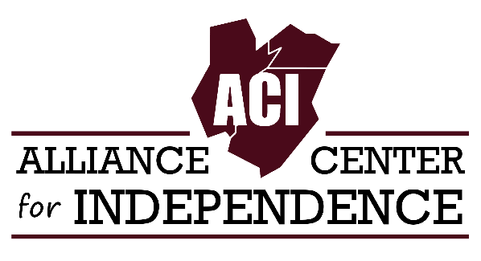
For Immediate Release
Carole Tonks
Executive Director
732-738-4388
ctonks@adacil.org

The Alliance Center for Independence Launches a New Disability Podcast!

EDISON, NEW JERSEY - The Alliance Center for Independence (ACI) has recently launched a podcast that focuses on issues important to people with disabilities in NJ and throughout the country. The first episode was dropped on August 30th.
Chica and the Disabled Dude is hosted by Brenda Cazares, ACI’s employment services coordinator, and Nybil Ghanem, ACI’s Information and Referral Specialist. Nybil, a wheelchair user with cerebral palsy, will provide his first-hand perspective on work, living independently and breaking down attitudinal barriers. Brenda, a Spanish speaker with vast experience in the disability field, will showcase the unique issues facing Hispanic people with disabilities.
The podcast will feature guest interviews and on location broadcasts. Upcoming topics include: sex and people with disabilities, voting rights, employment, etiquette and accessibility.
“We are looking forward to a lively chat about the issues that people with disabilities and their families can relate to.” said Nybil. Brenda added, “We will provide a fresh perspective, an informative approach covering different angles.”
Chica and the Disabled Dude can be found on Spotify, Apple and other podcast platforms. You can listen to the first episode here: spotifyanchor-web.app.link/e/HwiN0JlgVsb
“It is our hope that this podcast will provide an open dialogue, while reaching people we typically do not reach.'' says ACI Executive Director, Carole Tonks.
ACI is a non-profit 501(c)(3) organization providing independent living skills and other services to people with disabilities and their families in Middlesex, Union, and Somerset counties. We are one of 12 independent living centers in NJ.
For more information, contact Carole Tonks at 732-738-4388 or ctonks@adacil.org or visit our website at adacil.org.

