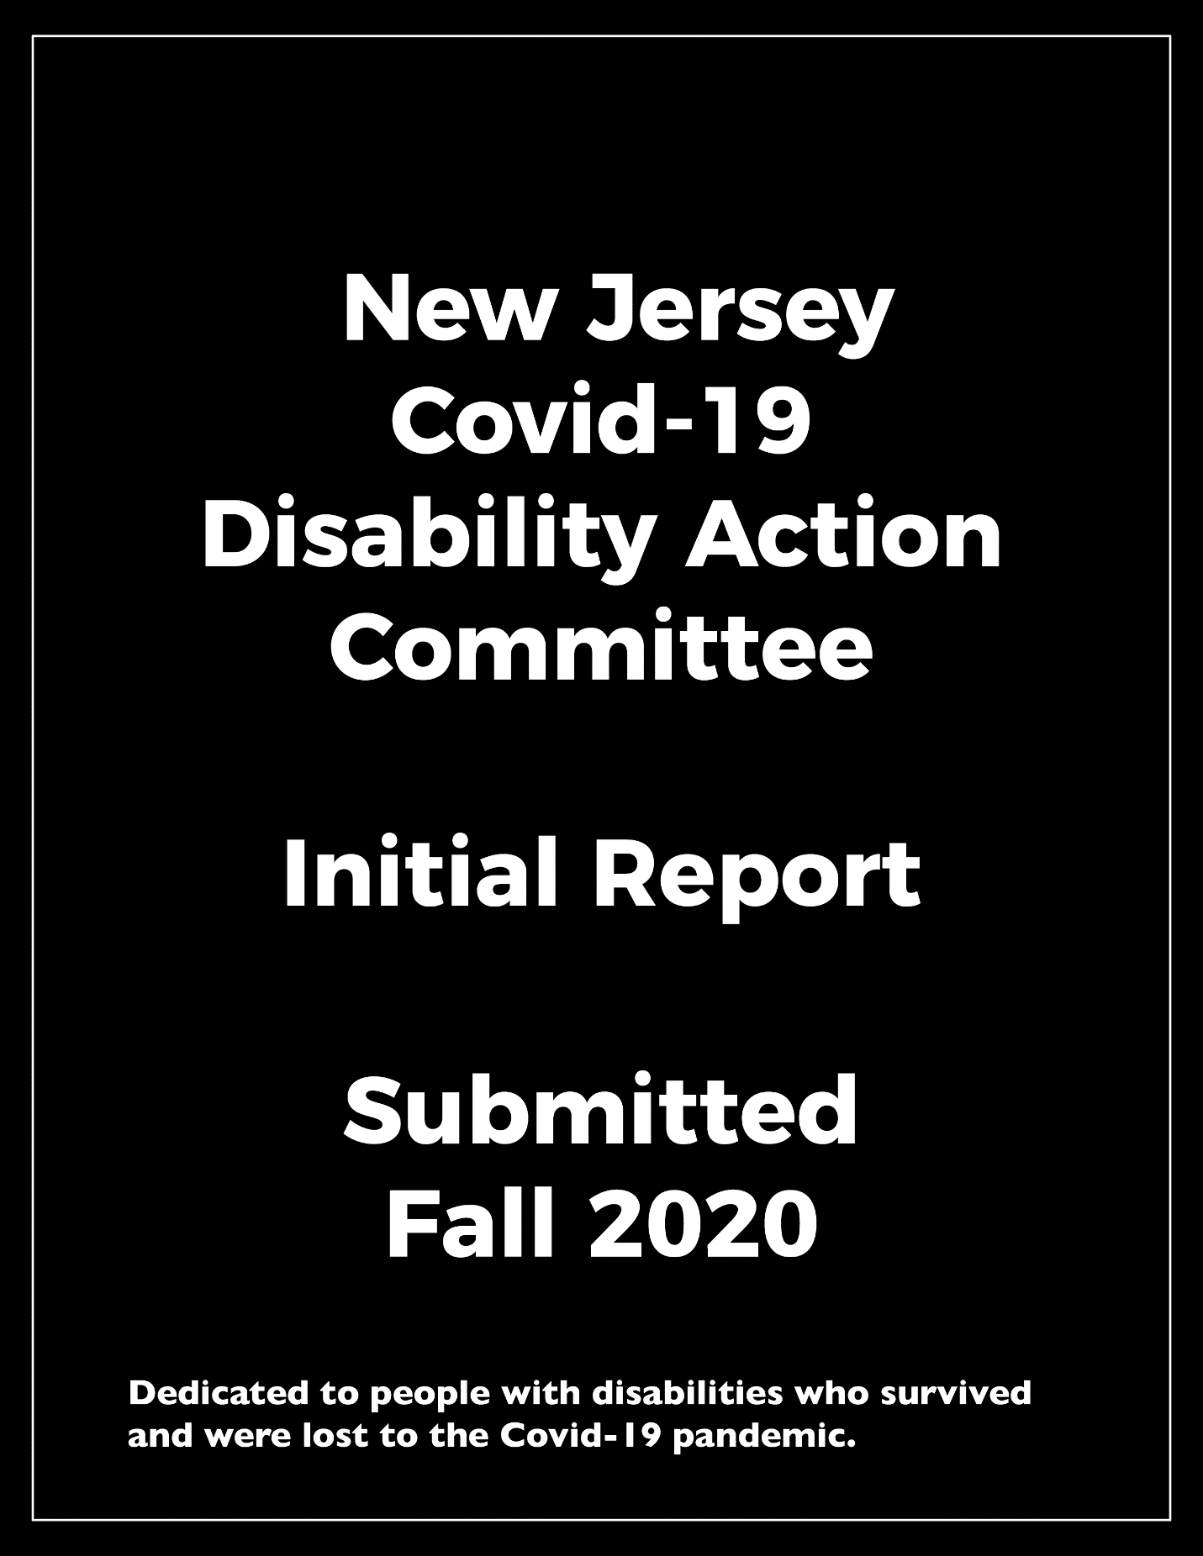

NJ COVID-19 Disability Action Committee Organizer Letter

I humbly submit this report on behalf of the NJ COVID-19 Disability Action Committee. This group of people with disabilities, family members of people with disabilities, advocates, and professionals dedicated hundreds of hours of their time and experience to ensure this report’s existence and recommendations.

The SARS-CoV-2 (COVID-19) pandemic that struck the United States and New Jersey has forever changed the lives of our community members, with and without disabilities. The turmoil caused by this pandemic and the sheer magnitude of those affected will be forever part of our collective experience. New York, New Jersey, and the surrounding States were at the center of the Covid-19 epidemic; this direct geographical hit challenged our community and state resources. Moreover, those most vulnerable, people of color, people with disabilities, and the elderly saw a disproportionate impact from the COVID-19 pandemic. This committee recognizes our state’s Governor and legislature’s important work and dedication for their on-hands battle to contain the COVID-19 epidemic and ensure that our state residents were protected. We applaud the brave commitment by the state’s front-line workers, volunteers, direct support providers, personal care assistants, visiting homemakers, and parents. It was this selfless commitment by this group of heroes and the disproportionate impact of COVID-19 on people with disabilities and their families in our state that was the impetus for this committee and report.

This group has relied on our members’ collective experience, who are as diverse as our State concerning disability, race, gender, ethnicity, and religion. The committee has consisted of people with disabilities, their families, the Center for Disability Sports, Health and Wellness, Rutgers University, New Jersey State Independent Living Council, New Jersey Council on Developmental Disabilities, parents, and business owners, advocates on disability issues, and. Lastly, we'd like to acknowledge the governor’s office’s efforts and the NJ Office of the Ombudsman for Individuals with Intellectual or Developmental Disabilities, which served as a committee resource.

The state of New Jersey has faced a devastating toll from the COVID-19 virus, which infected our most vulnerable residents, often with fatal results. As of this letter’s writing, the United States has surpassed 8.9 million Covid-19 cases, with 227,697 dead. In New Jersey, we have lost 16,324 lives, with 234,790 infected. The Institute for Health Metrics and Evaluation estimates that by January of 2021, there could be as many as 385,6111 dead in the United States and 2,400,343 globally due to COVID-19. According to the Centers for Disease Control (CDC), while all people with underlying chronic health conditions are at higher risk of severe illness, people with disabilities are three times more likely than those without to have these underlying conditions, such as diabetes, stroke, disease, or cancer. According to Scott Landes, an associate professor of sociology at Syracuse University's Maxwell School of Citizenship and Public Affairs, people with developmental disabilities living in a congregant setting have some of the highest death rates from COVID-19 in the US. They are four times more likely to contract COVID-19 and twice as likely to die from it than the general population.

People with disabilities and their family members remain vigilant of their vulnerability to COVID-19. The economic impact on families and their burden on individual health is an existential threat to this community. A vaccine may be months or a year away, depending on the news cycle. In the meantime, our state’s health and social justice mechanisms must protect the health and wellness of people with disabilities and uphold their federal, civil, and state rights. We must do better, and we must prepare now for the next wave of this pandemic, the following national catastrophe, or any other emergency that awaits us in the future. People with disabilities cannot be left behind again! Their voices must be heard and acknowledged in the statehouse, legislature, and board room. The only way to ensure that the right voices are represented at the table as it relates to the disability community is to have people with disabilities and loved ones at the table.

More than ever, this pandemic has focused a spotlight on the marginalization of the voices, needs, and rights of people with disabilities not just in New Jersey but nationwide. Additionally, the rights of parents of individuals with disabilities have been abrogated, and their voices are silenced by medical and political leaders. For example, many of those who fought wars so that we may be free have perished in the most undignified manner possible in nursing and veteran homes. The lack of personal protective equipment for people with disabilities, their families, and, just as importantly, those who work for them have had deadly consequences. Moreover, people of color who have disabilities fall in the highest risk category for this virus as they have been dually affected by a lack of information and treatment. Let us also not forget that testing continues to be a challenge to acquire and, in some cases, to administer to individual members of our community due to their specific disabilities. Waiting for test results can take close to two weeks at times, which seems rather unfair when major league baseball players can get results in only two days.

This committee submits the New Jersey COVID-19 Disability Action Committee Report with our experience and recommendations for our state’s residents with disabilities’ future resiliency. This report takes a broad look at the State’s systems and functions and how they impact people with disabilities, their families, and service provider networks. The report will include recommendations for new legislation and changes to existing laws or policies to address inequalities during the pandemic. Lastly, a number of the lessons learned by our distinguished Committee members will be prevalent throughout the report. As previously noted, a central lesson is that in all matters related to COVID-19 in New Jersey, people with disabilities and their parents or loved ones must be at the table.

The committee anticipates that we may miss issues and recommendations from our vast and diverse community of people with disabilities. We view the submitted report as a living document updated based on concerns and achievements by and for people with disabilities.

My best,
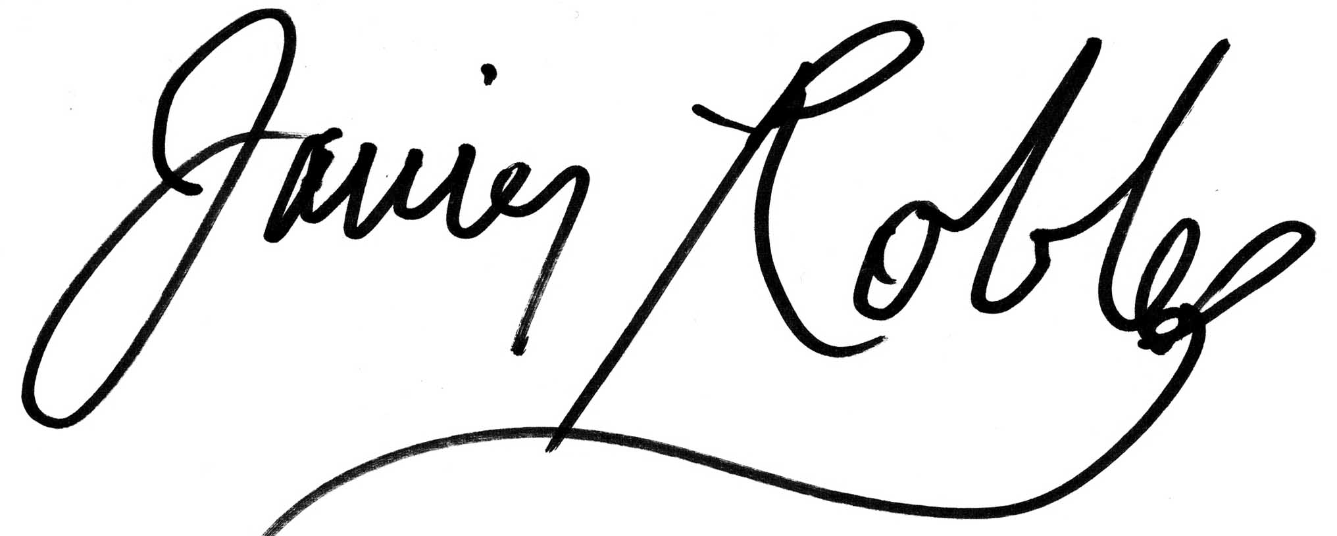
Javier Robles

Director, The Center for Disability Sports, Health and Wellness at Rutgers University

Table of Contents
NJ COVID-19 Disability Action Committee Organizer Letter 1
Table of Contents 6
Who We Are 9
Executive Summary 10
Committee Mission and Vision Statements 14
Report Objective 15
Current State of the Pandemic 16
SARS-CoV-2 and the Global COVID-19 Pandemic 17
NJ’s Contemporary History with COVID-19 19
Do Not Attempt Resuscitation Orders 19
Life-Saving Policies 22
Recommended Actions 23
Long-Term Care Facilities 25
The Manatt Report 26
Structural Recommendations 28
Structural Recommendations Context and Descriptions 29
Emergency Preparedness Recommendations 32
Context Supporting Emergency Preparedness Recommendations 33
Accessible Communication Needs 36
Context Supporting Accessible Communication Requests 37
Direct Care Worker Needs 41
Context Supporting Direct Care Worker Needs 44
Supporting Those in Long Term Care Facilities 47
Context for Supporting Those in Long Term Care Facilities 48
Resiliency Needs of the Disability Community 51
Context Supporting the Resiliency Needs of the Disability Community 52
Legal Landscape for People with Disabilities 61
Letter from the NJ Council on Developmental Disabilities 69
Letter from the NJ Statewide Independent Living Council 71
A Letter from a Parent Perspective 73
Letter from Sherlock Washington 75
Letter from the Ombudsman for Individuals with Intellectual or Developmental Disabilities and Their Families 76
Directory 77
Works Cited 99

A Note on Navigating this Document: We recognize the length of this document can be intimidating. However, we want this document to serve as a practical resource for our community. As a result, we have added the following features to hopefully increase its usability:

- You can click on different headings in the Table of Contents to be directed to the corresponding sections.
- To return to the Table of Contents at any time, you can click the link in the bottom left corner of each page.
- You can click on the recommendation headings of the Executive Summary to be directed to the corresponding sections of the report.

Accessibility Features:

Throughout this document, we use a Sans Serif font of at least size 14 to help make it easier for people with visual impairments and visual processing disorders to read.

We have incorporated image descriptions below each photo in our directory to include our blind and low vision community members.

We have also made this document available for download as both as PDF and as a Word Document to help increase accessibility for people who use assistive technology such as screen readers.

Moving forward, we also hope to make our documents multi-lingual and plain language to make them accessible to more community members.

If you have additional suggestions to increase our accessibility, please contact us at NJDisabilityActionCommittee@gmail.com. We look forward to learning from you!

Who We Are
The Disability Action Committee is a diverse group of individuals from across the state of NJ that are a part of the Disability Community. Our committee includes self-advocates, family/caregiver advocates, and support professionals. We assembled during the COVID-19 pandemic when it became clear that people with disabilities and their loved ones were going to bear the consequences of this crisis disproportionately. According to the New Jersey Department of Human Services, there are an estimated 1.7 million residents with disabilities in New Jersey.
Once assembled, we immediately went to work conducting research and creating reports to advocate for our community’s needs. We intend to start disseminating these reports soon. So far, we have invested over 500 volunteer hours’ worth of work.
We aim to collaborate with the governor, legislators, others and offer our perspective so that future legislation considers the needs of all NJ residents.
In the directory, you can find information about our committee members and how to contact us. We look forward to working with you to make meaningful changes that will improve all New Jersey residents’ quality of life.
Special Thanks
This report was developed as a combined effort by a group of dedicated volunteers who worked hard, researched, met with each other independently, and wrote this report. The committee is incredibly grateful for the efforts and hard work of Rose Greenblatt. Her dedication to people with disabilities and their families is evident in her commitment to our group and report.

Executive Summary
The COVID-19 pandemic has laid bare the nation's structural deficiencies and the State's public health infrastructure. People with disabilities have been among the hardest hit. The State's leaders have made Time-sensitive pandemic response decisions without sufficient input from the disability community. The resulting policy and programmatic choices have been disastrous for people with disabilities, from triage algorithms that barred or demoted people from care solely based on existing disability to failures to ensure that people with disabilities could access health care and essential commodities. Moving forward, as we brace for the fall and winter seasons, the needs of the disability community must be central in policymaking.

In 2018, The CDC estimated that 24.6% of New Jersey adult residents had a disability. The disability community is diverse, both in terms of the types of disabilities with which individuals live and other dimensions of diversity, such as race/ethnicity, gender identity and sexual orientation, age, immigration status, and social class. The CDC estimates that individuals with disabilities in New Jersey broken up by race are as follows, 17.5% Asian, 20.5% white, 25.9% black, and 30.6% Hispanic for individuals 18 years or older with the general category of any disability.

Our committee strives to recognize the fullness and complexity that diversity brings to the disability community and reflect it in the recommendations made throughout this report. The following are the immediate recommendations of our committee. To find background and context surrounding these recommendations, see subsequent sections of this report.

Structural Recommendations

- Ensure that people with disabilities and their families are represented in all departments, boards and committees, and government task forces across the state.
- Develop a structure within the NJ state-level government that elevates the voices of people with disabilities, so an ad hoc group of volunteers, such as this committee, does not need to assemble.
- Require that the Department of Health appoint people with disabilities and families of people with disabilities to provide specific recommendations during public health emergencies on issues surrounding life-sustaining measures, such as ventilators and Do Not Attempt Resuscitation orders, as well as testing and vaccinations.
- Change the Office of the Ombudsman for Individuals with Intellectual or Developmental Disabilities and Their Families to the Office of the Ombudsman for People with Disabilities and Their Families

Emergency Preparedness Recommendations

- The New Jersey Office of Emergency Management should create at least four full-time positions devoted to specifically addressing the access and functional needs of people with disabilities before, during, and after emergencies and disasters. With one supervisor and three planners to serve the needs of South, Central, and North Jersey regions to help the estimated 24.6% of NJ residents who have disabilities.
- The New Jersey Group for Access and Integration Needs in Emergencies and Disasters (NJGAINED) needs to be moved back to NJOEM and given statutory standing and authority. Representation from all State Divisions dealing with disability issues and the statewide Disability Rights organizations listed on page 33 must be mandated.
- Centers for Independent Living (CIL) should be incorporated into the Emergency Operation Plan (EOP) to conduct activities that utilize their expertise within Emergency Support Function (ESF) 6 (Mass Care) and elsewhere throughout the plan.
- CILs should have permanent representation on Functional Assessment Service Teams (FAST).
- A year-long disability hotline should be established and run by people with disabilities in the 11 CILs throughout the state (see bills A4202 and S2632).
- Lines of communication and transparency and accountability structures must be strengthened between NJOEM and the New Jersey Department of Health (NJDOH) and other stakeholders and partner agencies.

Accessible Communication Recommendations

- Establish design and manufacturing standards for clear masks that are appropriate for medical and educational settings. Guidance should be provided on what models currently exist that meet these standards.
- An awareness campaign needs to be established to convey the need for people to use clear masks as it has a profound functional impact on people with hearing loss.
- All NJ documents must meet WCAG 2.0 guidelines for accessibility so that people who utilize screen readers and other compatible devices can stay up to date.

Direct Care Workforce Recommendations

- Direct care workers must be considered essential workers during emergencies, and they must be provided with the PPE, testing, and contact tracing necessary for them to serve their clients safely.
- The Direct Support Professional (DSP) State of Emergency wage increase of $3.00 per hour, which was made for DSPs working in group homes and supervised apartments, must be extended to DSPs supporting individuals across all types of services.
- A streamlined Emergency Worker Training for new DCWs through either the College of Direct Support or another similar organization to effectively prepare new workers, including family members, stepping in to help provide care during this crisis must be developed and implemented.

Long Term Care Facility Recommendations

- Establish guardian/family representation at the agency level with respect to policies affecting Developmental Centers’ residents, and require regular meetings between state agencies’ administrators overseeing the Centers’ operations and residents’ representatives ongoingly, not only after the fact of emergency declarations.
- End the practice of placing individuals with intellectual disabilities (IIDs) who do not need skilled nursing care in nursing homes.

Resiliency Recommendations

- Make telehealth a permanent option as it significantly improves the quality of life for NJ residents. Ensure that it meets standards discussed in the accessible communication section.
- Make permanent the authorization to use Electronic Benefit Transfers (EBT) for grocery delivery services.
- Clear documentation of employment accommodations that were made due to the pandemic that was not previously afforded to people with disabilities.
- A thorough evaluation of all transportation options available to people with disabilities and making it possible for people to use their disability budgets to utilize spontaneous and unplanned rideshare services such as Uber and Lyft.
- Expanding hospital visitation rights for people with disabilities beyond intellectual and developmental disabilities.

Committee Mission and Vision Statements

Mission Statement
To identify the needs of New Jersey residents with disabilities during and after the COVID-19 pandemic and to ensure that they and their support network have equal and ethical access goods and services, to prevent unnecessary suffering and burden, and to create a resilient New Jersey where people with disabilities not just live but thrive in settings of their choice and to reaffirm the value of their lives.

Vision Statement
To develop social, economic, and physical structures that will provide people with disabilities in the state of New Jersey the tools to be protected in times of crisis or pandemics, to live where they want and be as independent as they wish to be or are capable of, and to be equal partners in a state that makes access to accessible, reliable and fair programs a priority for them.

Report Objective
The objective of this report is to introduce state government officials and relevant stakeholders to the current state of people with all types of disabilities in New Jersey. This is a living document that will grow with the needs of people with disabilities during the pandemic and beyond.
We hope this document will ensure equal value placed on our community, fairer access to lifesaving treatments, and a spotlight on the disability community’s resiliency. We must make it possible for the concerns of people with disabilities across the state to be heard and recognized to collaborate to bring about meaningful change for our vulnerable populations and benefit our society as a whole.
Recognizing and upholding the equal inherent human dignity of all people, the authors individually and collectively offer this report, both as an accounting of the ways in which state response efforts failed the disability community, and as a set of interim recommendations to put front and center, to protect people with disabilities.
The information contained within is based upon best-available scientific evidence at the time of writing and may be subject to change as additional discoveries come to light.

The Disability Action Committee intends to create future documents that will be forwarded to a similar collection of state government officials and other relevant stakeholders so that everyone remains informed as the state of people with disabilities in New Jersey evolves.

Current State of the Pandemic
The global COVID-19 pandemic presents challenges for society at once acute and myriad, unlike any other natural or social crisis, leaving no aspect of modern life untouched. Schools are still in flux, and, workplaces and workforces are in uncertain transition, the global economy is ravaged, the pandemic’s end is unknown, and the lives of untold millions are still in the balance.
While there are still many unanswered questions, we learn a bit more about the virus and how to respond each day. This report presents lessons learned about COVID-19 and pandemic preparedness and response in New Jersey, focusing on the disability community. As one of the nation’s hardest-hit states in the early days of COVID-19, New Jersey has experiences and lessons to share with other states, as well as to inform its own pandemic preparedness efforts (either in response to subsequent waves of COVID-19 or other infectious disease threats). Much of the learning was costly, paid for in significant human misery and loss of life. The purpose of collating this information in a report while the state and the nation continue to operate with considerable uncertainty is to prevent further unnecessary suffering.
Recognizing and upholding the equal inherent human dignity of all people, the authors individually and collectively offer this report, both as an accounting of the ways in which state response efforts failed the disability community, and as a set of interim recommendations to put front and center, to protect people with disabilities.
The information contained within is based upon best-available scientific evidence at the time of writing and may be subject to change as additional discoveries come to light.

SARS-CoV-2 and the Global COVID-19 Pandemic
Coronavirus Disease 2019 (COVID-19) is an acute viral infection caused by SARS-CoV-2, a novel coronavirus that first emerged in Wuhan, China, in late 2019. The virus that causes COVID-19 is related to other coronaviruses that cause severe, acute respiratory distress such as Severe Acute Respiratory Syndrome (SARS) and Middle East Respiratory Syndrome (MERS), as well as to other coronaviruses that cause more mild infections including certain strains of the common cold. It is believed that the virus causing COVID-19 had never before infected humans prior to the start of the current pandemic (Hu et al., 2020).
The full range of symptoms of SARS-CoV-2 infection may still not yet be known. Reported symptoms include fever; sudden loss of taste or smell; cough; fatigue; sore throat; shortness of breath and difficulty breathing; headache; body and muscle aches; nausea or vomiting; diarrhea; rashes or blisters on fingers or toes; and conjunctivitis (pink eye) (CDC “Symptoms of Coronavirus”, 2020 & WHO “Coronavirus”, 2020). Some people develop a mild infection that clears with bedrest. Others may require hospitalization and extensive medical intervention. Still others seem to never develop a symptomatic response. It is still unclear which risk and protective factors are associated with different clinical progressions of the disease, though it is suspected that people with underlying respiratory, cardiac, and immunosuppressive conditions may be particularly vulnerable to severe adverse outcomes (Jordan et al., 2020). However, emerging research indicates that people with a wide range of disabilities are disproportionately affected by the virus, via both vis-à-vis biological vulnerabilities and clinical and political decision making processes that devalue their lives and wellbeing (CDC “People with Disabilities”, 2020 & Turk, 2020).
Notably, a significant proportion of people with COVID-19 infection continue to experience COVID-19 symptoms weeks and months after initial infection; it is still unknown how common such long-term complications are, how long symptoms will persist, and whether infection can produce long-term or permanent disability. For example, disability advocate Mia Ives-Rublee has also raised the possibility of parallels between COVID-19 and post-polio syndrome (Ives-Rublee, 2020). COVID-19 “long-haulers” experiencing a post-viral syndrome similar to myalgic encephalomyelitis (ME) report brain fog, fatigue, pain, immune issues, and malaise after exercise (Greenhalgh et al, 2020; Lokugamage et al., 2020; & Mahase, 2020). In the absence of concrete knowledge about the extent of long-term complications, it seems prudent to develop systems that detect, identify, plan and prepare for long-term sequelae.
Though the virus initially emerged in China, the United States is currently the primary global COVID-19 hotspot. As of the time of publication, the US caseload comprised 20 percent of global confirmed cases, though this proportion is shifting as the pandemic takes hold in populous low- and middle-income countries such as India and Brazil. The US also has one of the world’s highest per population death rates, with nearly 69 deaths per 100,000 people (Center for Systems Science and Engineering at Johns Hopkins University, 2020). There are useful lessons to be learned from other countries in how to prevent, contain and mitigate widespread infection. While these lessons are beyond the scope of the current report, they will help inform how to protect populations in which people with disabilities are embedded, and so should be mainstays of future preparedness and response work.

NJ’s Contemporary History with COVID-19

Do Not Attempt Resuscitation Orders

It became all too obvious during the height of the pandemic that states would resort to any means necessary to protect a utilitarian model the greatest good for the greatest number. On March 25, 2020 an article in, Becker's Hospital Review, titled, ‘We’re going to be coding dead people': Hospitals consider do-not-resuscitate order for all COVID-19 patients, the focus was on a national trend toward hospitals considering Do Not Attempt Resuscitation (DNAR) for COVID-19 patients against the wishes of their families or individuals. Many of the reasonings included issues of health and safety for the healthcare workers as well as issues of available resources. These draconian proposals and in some eventualities actual policies showed a nation clearly not prepared for a national crisis. (Masson, 2020)

From Washington state to New York State hospitals, medical professionals and elected politicians were ready to pull the trigger and, in some cases, did on this policy.

New Jersey at the height of the pandemic had a patchwork of hospitals and medical personnel under serious duress due to staff shortages and lack of personal protective equipment (PPE). In addition, the numbers of newly infected COVID-19 patients overwhelmed New Jersey hospital emergency rooms and bed capacity. Therefore, hospital systems like Hackensack Meridian Health, New Jersey's largest hospital system, placed a Do Not Attempt Resuscitation (DNAR) policy for its network. St. Joseph's University Medical Center in Patterson followed suit and ordered a "no CPR" list at their hospital. (Sargent, 2020)

These policies, according to the article, "aim to mitigate the transmission risk inherent in lifesaving measures, such as CPR and intubation when patients stop breathing or their hearts cease beating". Not all hospitals saw the need for this policy. Holy Name in Teaneck opted out and WRJ Barnabas Health stated that it would defer to the NJ Department of Health guidelines on resuscitation or other lifesaving measures. The New Jersey Commissioner of Health, Judy Persichilli, stated that New Jersey would "unequivocally" not implement a blanket DNAR for individuals infected with COVID-19. (Sargent, 2020)

These policies whether supported by the state of New Jersey or hospitals within the state raise a number of ethical issues concerning patient rights as well as questions of consent. It is well documented that individuals who became ill with COVID-19 and were forced to seek medical help were often alone and, in some cases, unable to make decisions based on their illness. There were no advocates or family members with them when these decisions were made. Individuals with disabilities who are unable to understand what is happening to them or those who are unable to communicate are highly vulnerable without their loved one’s present. The New Jersey Department of Health was against a blanket DNAR order which would have been devastating to our community. However, a lack of comprehensive and clear policies during a time of crisis in our state led to doctors and nurses being called upon to decide who lives and who dies. This is unacceptable in a progressive state that values life and individual autonomy. (Sargent, 2020)

People with disabilities and the most marginalized should be able to rely on the state apparatus to protect their rights and freedoms at all times. If individuals have opted through their living wills or family proxy to choose or not to choose a DNAR that is a personal and justifiable decision. Family members must be involved at all times regardless of national crisis. We must respect an individual's right to choose or not to choose extension of life treatment. The state of New Jersey must develop a statewide plan of action which encompasses the rights of its residents in the face of statewide crises such as COVID-19 or other pandemics. It is unfair to people with disabilities to leave these decisions to hospitals or doctors when it is already too late. The state must mandate a universal policy which protects the rights of its most vulnerable. Moreover, no policy or mandates should be implemented without the input and clear buy-in from people with disabilities and their families. Individuals with disabilities and family members should serve on all state, nursing home and hospital boards to ensure that their interest is being served. One thing that has been clear since this pandemic began is that people with disabilities have not had a voice in the state for a long time. That cannot continue and the only way to be accountable is to have members of the disability community everywhere.

In its bulletin dated March 28, 2020 the Office of Civil Rights (OCR) at the US Department of Health and Human Services (HHS), stated on the issue of the pandemic and disability discrimination that:

“In this time of emergency, the laudable goal of providing care quickly and efficiently must be guided by the fundamental principles of fairness, equality, and compassion that animate our civil rights laws. This is particularly true with respect to the treatment of persons with disabilities during medical emergencies as they possess the same dignity and worth as everyone else.:”
(Rights, 2020)

The bulletin covers a number of issues on discrimination which are important to note in this report.

First, persons with disabilities should not be denied medical care on the basis of stereotypes. Second, assessments of quality of life, or judgments about a person's relative "worth" should not be based on the presence or absence of disabilities or age. Third, decisions concerning whether an individual is a candidate for treatment should be based on individualized assessments of a patient based on the best available objective medical evidence.

New Jersey must have a clear path towards providing care during a time of crisis to individuals with disabilities. This must include an unbiased approach that realistically treats individuals with dignity and carefully follows the individuals wishes for life-sustaining care. Medical professionals should be entrusted to follow the state guidance on treatment and care of people with disabilities, it should not be that the state looks for medical practitioners to make life-and-death decisions on their own, or with little oversight. This appears to have been the case of Michael Hickson, a 46-year-old quadriplegic who was admitted to St. David's South Austin Medical Center for COVID-19.
Mr. Hickson died after being moved to a hospice center from the intensive care unit. According to his wife, Melissa Hickson, doctors at the hospital decided to deny him potentially life-saving treatment due to his disabilities and low quality of life. The hospital has countered that its decision was based on Mr. Hickson's prognosis and stated that it would have been pointless and cruel to give him invasive treatment. This case has garnered national and international attention for its callous disregard for the life of an individual with a disability. The National Council on Independent Living and ADAPT of Texas, a disability rights group have filed a complaint with the office for civil rights at the Department of Health and Human Services. (Texas, 2020)

In the complaint filed by the National Council on Independent (NCIL) Living on behalf of Michael Hickson, it is asserted that Saint David South Austin Medical Center and its affiliates illegally discriminated against Mr. Hickson. The following is verbatim from their complaint:

“This complaint is asserting violations of the Americans with Disabilities Act, Section 504 of the Rehabilitation Act, Section 1557 of the Affordable Care Act (ACA), and OCR Guidance Bulletin “Civil Rights, HIPAA, and the Coronavirus Disease 2019 (COVID-19)” issued March 28, 2020, based on the withholding of life-sustaining care and treatment for the former patient of St. David’s South Austin Medical Center, Michael Hickson. This withholding of care and treatment, based on the discriminatory application of care and treatment decisions based on Mr. Hickson’s disability, resulted in his premature death on June 11, 2020.” (Living, 2020)

Life-Saving Policies

Individuals with disabilities, their allies and family members understood early on in the pandemic that our community was in danger of being denied life saving treatment and equipment. The state of Alabama and its Department of Public Health had a complaint filed against them through the Office of Civil Rights at the US Department of Health and Human Services. This complaint was filed by the Alabama Disabilities Advocacy Program and the ARC of the United States. (Services, 2020)

These two disability rights agencies believed that the state of Alabama had incorporated a 2010 document called, the "Criteria for Mechanical Ventilator Triage Following Proclamation of Mass-Casualty Respiratory Emergency". This 2010 Criteria was an annex to the states Emergency Operations Plan. According to the complaint, the 2010 Criteria allowed the state to deny ventilator services to individuals with disabilities, and certain elderly individuals. (Services, 2020)

“Criteria for Mechanical Ventilator Triage Following Proclamation of Mass-Casualty Respiratory Emergency” (2010 Criteria) as an annex to its Emergency Operations Plan. The 2010 Criteria allegedly allowed for denying ventilator services to individuals based on the presence of intellectual disabilities, including “profound mental retardation” and “moderate to severe dementia.” (Services, 2020)

Other states such as, Kansas, Tennessee and Washington had similar, rationing policies, which are often called, "crisis the standards of care". The combination of the Alabama 2010 Criteria and these other states prompted the, United States Department of Health and Human Services, Office of Civil Rights, to issue a bulletin on March 28, 2020 that their state plan should not discriminate. (Whyte, 2020)

Recommended Actions

The committee urges the state of New Jersey to follow the lead of the Federal Office of Civil Rights in the recent resolution with the state of Utah on the issue of lifesaving treatment for individuals with disabilities. Utah has revised it Crisis Standard of Care Guidelines to comply with federal laws that prevent discrimination against people with disabilities, even in times of public health emergencies.

- Under the new Utah Crisis Standard of Care Guidelines, hospitals must provide people with disabilities information on all available treatments and alternatives, and hospitals may not impose a blanket Do Not Resuscitate (DNR) policy.

- Physicians shall not require patients to consent to advance care planning decisions in order to receive hospital services.

- Hospitals and or physicians shall not exclude or prioritize people with disabilities based on disability diagnosis or resource intensity. A person cannot be excluded from, or de-prioritized for treatment merely because they may require more time or resources for recovery or because they may have a disability diagnosis or functional impairment.

- Utah has eliminated long-term survivability as a treatment condition in its decision-making guidelines. This will allow hospitals and medical personnel to only consider "short-term mortality.” The assumptions of quality of life and lifespan of people with disabilities which are based often on stereotypes will be eased by this rule.
- Utah's new guidelines also require hospitals and medical personnel to make modifications to the Modified Sequential Organ Failure Assessment (MSOFA). These modifications will assist in not penalizing people with underlying conditions that are unrelated to the individual's ability to benefit from treatment. In addition, reasonable modifications may be required to provide equal access to treating patients with disabilities.
- Although there is no reason to believe that we've had this issue in the state of New Jersey, Utah’s guidelines also prohibit the reallocation of personal ventilators from individuals who use these in their daily lives to those deemed to have greater probability of survival.

Resolution of Federal Complaint Filed by CPR and Partners Sets National Precedent Against Blanket DNRs, Medical Discrimination on the Basis of Disability During the COVID-19 Pandemic, August 20, 2020
https://www.centerforpublicrep.org/news/resolution-of-federal-complaint-filed-by-cpr-and-partners-sets-national-precedent-against-blanket-dnrs-medical-discrimination-on-the-basis-of-disability-during-the-COVID-19-pandemic/

OCR Resolves Complaint with Utah After it Revised Crisis Standards of Care to Protect Against Age and Disability Discrimination, August 20, 2020
https://www.hhs.gov/about/news/2020/08/20/ocr-resolves-complaint-with-utah-after-revised-crisis-standards-of-care-to-protect-against-age-disability-discrimination.html

Long-Term Care Facilities

As early as April 23, 2020 The Kaiser Family Foundation (KFF) stated in their article, "State Reporting of Cases and Deaths Due to COVID-19 and Long-Term Care Facilities" stated:’

"COVID-19 has had a disproportionate effect on people who reside or work in long-term care facilities, including the 1.3 million individuals in nursing homes; 800,000 in assisted living facilities; 75,000 in intermediate care facilities; and 3 million people who work in skilled nursing or residential care facilities."
(Chidambaram, 2020)

The state of New Jersey suffered immense loss of life at its facilities, including, nursing homes, veterans homes, assisted living facilities,, and community settings. The deaths that occurred at these facilities included both staff and residents and represent close to half of all statewide deaths due to COVID-19. To date the beginning of this pandemic in the state of New Jersey, estimated to be in February, have been a total of 7,046 dead in these facilities. There have been 6,703 resident deaths reported and 121 staff deaths reported (NJ COVID-19 Long-Term Care Facilities Dashboard, 2020).

According to the Centers for Disease Control, New Jersey is only second to Connecticut in the number of average COVID-19 cases per 1000 residents. New Jersey has an average of 354.7 cases per 1,000 as compared to Connecticut which has 355.9 per 1,000. New Jersey is also second only to Massachusetts in resident average deaths per 1,000. New Jersey has an average of 116.5 resident average staff per 1000 to Massachusetts 124.7 deaths per 1,000. These numbers are illustrative of the amount of work that needs to be done to ensure the health and safety of residents and staff at long-term care facilities (Data.CMS.Gov, 2020).

Residents of nursing homes under the Nursing Home Reform Law of 1987 are entitled to certain standards and rights. This is true for all levels of nursing home care in the state where nursing homes receive payments from Medicare or Medicaid. The current estimate is that about 80% of all nursing homes in the United States receive these payments.

The Manatt Report

The Manatt report submitted under contract to the state of New Jersey on June 2, 2020, entitled, Recommendations to Strengthen the Resilience of New Jersey's Nursing Homes in the Wake of COVID-19, answered some questions concerning the state of nursing homes and its residents and staff. However, it also raised many questions, especially since the report investigation happened during the lockdown and in the heat of the pandemic. According to its report, Manatt was charged with providing New Jersey with actionable recommendations for the near-term and long-term. The research group, over a three-week timeline, conducted over 50 interviews, performed a literature review, a data review as well as an evaluation of best practices and actions undertaken by other states (Manatt, 2020).

According to Manatt, there were a number of limitations to its report. Some of these limitations in the information that would have been derived from them, we believe, is of extreme value to people with disabilities in the state of New Jersey (Manatt, 2020).

These limitations were as follows:

- This report was developed over a three-week period when the COVID-19 landscape in New Jersey was changing rapidly. The recommendations in this report are informed by the most up-to-date information at that point in time, but Manatt recognizes that week to week – and often day by day – there are new developments and information relating to the COVID-19 crisis.
- The primary focus of this report is skilled nursing facilities (SNFs), nursing facilities, and special care nursing facilities (collectively referred to in this report as nursing homes) licensed by the state of New Jersey, rather than the full range of congregate care settings that operate in the state. Additional work may be done to identify which of these recommendations can be extended to those care settings. The term “LTC facilities” is used when recommendations apply to facilities beyond nursing homes.
- While this report is about nursing homes, the people who reside in nursing homes have diverse needs. They include people with short- and long-term stays, people with dementia, serious mental illness, traumatic brain injury, and intellectual/developmental disabilities.
- Because this report was developed during statewide “stay-at-home” orders and while nursing home visitation was restricted, Manatt did not conduct any in-person visits to nursing homes. Instead, Manatt held video and telephonic calls with many stakeholders, including a sampling of facilities, as well as trade associations, labor representatives, consumer advocates, and many others. In the future, in-person visits could further inform these recommendations.
- This report highlights a set of recommendations deemed to be high-impact actions that the State can take. It does not represent the full spectrum of actions and improvements that the state may want to consider. Many of the recommendations in this report are interdependent.
- Importantly, the implementation of many of these recommendations will require further planning and statutory or regulatory changes, and many of these recommendations will require additional funding (Manatt, 2020).

Structural Recommendations
- Ensure that people with disabilities and their families are represented in all departments, boards and committees, and government task forces across the state.
- Develop a structure within the NJ state-level government that elevates the voices of people with disabilities, so an ad hoc group of volunteers, such as this committee, does not need to assemble.
- Require that the Department of Health appoint people with disabilities and families of people with disabilities to provide specific recommendations during public health emergencies on issues surrounding life-sustaining measures, such as ventilators and Do Not Attempt Resuscitation orders, as well as testing and vaccinations.
- Change the Office of the Ombudsman for Individuals with Intellectual or Developmental Disabilities and Their Families to the Office of the Ombudsman for People with Disabilities and Their Families

Structural Recommendations Context and Descriptions

Recommendation A: Ensure that people with disabilities and their families are represented in all departments, boards and committees, and government task forces across the state.

People with disabilities have historically been excluded from decision making positions within the government. People with disabilities and their families should be present with all major aspects of government functioning. We would like the governor and legislature to develop a statewide resume bank for people with disabilities and their families from which the governor and legislature can pick committee and board members based on their specific interests. As 10-24.6% of NJ residents are considered disabled, 10-24% of all committees and task forces should consist of people with disabilities.

Recommendation B: Develop a structure within the NJ state-level government that elevates the voices of people with disabilities, so an ad hoc group of volunteers, such as this committee, does not need to assemble.

From us coming together and from us working, we see the need for a formalized structure to be created so that this doesn’t happen again. We need a group that works together within the government to bring a unified voice regarding the needs of people with disabilities to the governor and state legislature.

Other states, such as Texas, Pennsylvania, and Washington, have developed formalized committees that advocate for the needs of people with disabilities at the state level by overseeing proposed legislation and reporting directly to the Governor. We would like to develop a similar structure that meets our state’s unique needs.
To see an example of some of these committees existing in other states, click on any of the links below:

TX Governor’s Committee on People with Disabilities
PA Governor's Cabinet and Advisory Committee for People with Disabilities
WA Governor’s Committee on Disability Issues & Employment (GCDE)

Recommendation C: Require that the Department of Health appoint people with disabilities and families of people with disabilities to provide specific recommendations during public health emergencies on issues surrounding life-sustaining measures, such as ventilators and Do Not Attempt Resuscitation orders, as well as testing and vaccinations.

The Governor's Office must institute a statewide group that includes people with disabilities, guardians, family members, and disability advocacy organizations along with the Department of Health, the Department of Human Service, The Department of Community Affairs, the Office of Ombudsman for Individuals with Intellectual or Developmental Disabilities and Their Families, The Office of the State Long Term Care Ombudsman and Disability Rights New Jersey which is the state’s P&A system, to work and develop a state plan for the allocation of ventilators or other life-sustaining and life-saving equipment and modalities. This should include a standardized procedure for who receives resuscitation in a crisis regardless of their disability, race, or health status. This group must develop ethical guidelines within the legal framework of laws that protect the civil rights of people with disabilities and their family members. The group must provide enforceable and sustainable recommendations that protect the integrity of the Hippocratic oath and respects the rights of people with disabilities in any medical, clinical, nursing home or other settings where their life may be at risk. This group should strongly reevaluate the current state regulations under the “Pittsburgh Test,” which is detrimental to many members of our community and people of color.

Recommendation D: Change the Office of the Ombudsman for Individuals with Intellectual or Developmental Disabilities and Their Families to the Office of the Ombudsman for People with Disabilities and Their Families

Changing the name of this office will allow the ombudsperson to serve the disability community more holistically. This is critical because there is a significant overlap between the needs of the different disability subgroups.

This pandemic has been instructive in need for seamless services that are not silo-like in their delivery. In an effort to move away from division by disability in order to receive equitable services New Jersey must have one Ombudsman office that protects the interest of all people with disabilities in the state. This is imperative in order that we may treat every person regardless of their disability as equal entities, entitled to protections these offices are intended to give. In addition, it is important to remember that all legislation made to protect people with disabilities or to offer them services should include the broadest definition of disability possible as per the Americans With Disabilities Act.

Emergency Preparedness Recommendations

- The New Jersey Office of Emergency Management should create at least four full-time positions devoted to specifically addressing the access and functional needs of people with disabilities before, during, and after emergencies and disasters. With 1 supervisor and 3 planners to serve the needs of South, Central, and North Jersey regions to serve the estimated 24.6% NJ residents with functional needs.
- The New Jersey Group for Access and Integration Needs in Emergencies and Disasters (NJGAINED) needs to be moved back to NJOEM and given statutory standing and authority. Representation from all State Divisions dealing with disability issues and the following statewide Disability Rights organizations
  - The NJ Statewide Independent Living Council
  - The NJ Council on Developmental Disabilities
  - Disability Rights - New Jersey
  - Other Disability and Emergency Management Stakeholders
- Centers for Independent Living (CIL) should be incorporated into the Emergency Operation Plan (EOP) to conduct activities that utilize their expertise within Emergency Support Function (ESF) 6 (Mass Care) and elsewhere throughout the plan.
- CILs should have permanent representation on Functional Assessment Service Teams (FAST)
- A year-long disability hotline should be established and run by people with disabilities in the 11 CILs throughout the state (see bills A4202 and S2632).
- Lines of communication and transparency and accountability structures must be strengthened between NJOEM and the New Jersey Department of Health (NJDOH) as well as other stakeholders and partner agencies.

Context Supporting Emergency Preparedness Recommendations
Crisis analysis often results in the discovery that communication and decision-making bodies are not working effectively. At this point in the arc of the pandemic, it is important to examine not only the public health response to COVID-19 but also how the structure of Emergency Management services and supports currently affects the disability community and make recommendations for realignment prior to the next wave.
According to Marcie Roth, former director of FEMA’s Office of Disability Integration and Coordination, the attacks of September 11, 2001, and the horrific aftermath of Hurricane Katrina revealed systematic gaps in planning for the functional needs of people with disabilities by emergency management systems. The needs were seen as “special” which called for separate planning strategies and, consequently, rendered this planning as mere “afterthoughts” in the overall planning process. This changed with the passage of the Post-Katrina Emergency Management Reform Act of 2006 and the filing of several federal civil rights lawsuits against large cities for discrimination against people with disabilities in their emergency planning. As a result, a national trend to include the access and functional needs of various populations within standard emergency planning emerged.
New Jersey was ahead of this national trend. Beginning in 1999, the New Jersey Office of Emergency Management (NJOEM) reached out to the disability community to seek input and provide training on emergency preparedness. The attacks of September 11, 2001 added impetus to this effort and resulted in the establishment of the NJ Special Needs Advisory Panel (NJSNAP). In the mid-2000s, NJSNAP had approximately 60 members from all segments of the disability community and emergency management fields. During this period, NJSNAP actively provided input to NJOEM and the NJ Office of Homeland Security & Preparedness (NJOHSP), were active on planning committees for both NJOEM and NJOHSP, participated in trainings for Emergency Management professionals, and provided Subject Matter Experts (SME) for table top exercises and drills. NJSNAP members were also active in H1N1 pandemic planning and response efforts in 2009.
Eventually, NJSNAP became known as the NJ Group for Access and Integration Needs in Emergencies and Disasters (NJGAINED) to reflect FEMA’s decision to use the terminology “access and functional needs (AFN)” instead of “special needs.” Organizational changes over the years moved NJGAINED leadership from NJOEM to the Department of Human Services Division of Disability Services, where it was restructured and largely neglected. This change felt like a demotion to some and was detrimental to the group’s ability to have input on emergency management policies and procedures. More recently, responsibility for NJGAINED has fallen within the NJ Department of Human Services’ Office of Emergency Management (DHSOEM). These changes have not restored the original purpose or intent of the group: to have input on emergency management policies and planning in all Emergency Support Functions affecting people with disabilities.
A major flaw in communications unearthed by our response to COVID-19, has been the lack of consultation with representatives from the disability community when life-or-death policy decisions are being considered. By comparison, during the H1N1 pandemic response, the Department of Health had representation on NJSNAP who brought similar issues to the group for input and “buy-in.” Unacceptably, during the first wave of COVID-19 the needs of people with disabilities living in New Jersey were afterthoughts despite years of discussions on ways to address them.
As the time for crisis analysis of the first wave of COVID-19 concludes, and we prepare and plan to mitigate the second wave's effects, The disability community at large and members of this Disability Action Committee should be consulted and utilized so as not to repeat recent history. For example, government officials and emergency planners have long recognized that Personal Care Assistance (PCA) services are essential during disasters, yet little effort has been made to ensure these services remain operational during a disaster. Although the Access and Functional Needs Planner at NJOEM consistently works to make sure PCAs can get to their clients, no official plans have been put in place to designate or identify PCAs as “essential workers” despite the fact that past emergencies and disasters have shown that such designation a would enable these workers to get to their clients much more reliably. This is especially important for PCAs directly hired by people with disabilities. Furthermore, there are no plans to provide PCAs with vital PPE, which places the burden on PCAs and their clients alone, to figure out how to protect themselves. This issue took weeks to get addressed through NJGAINED and other avenues; proper planning with the disability community would have mitigated some of this.
Another resource that remains unengaged are the State’s 11 centers for independent living (CILs). These state and federally-funded organizations provide services to people with disabilities, regardless of type or age of onset in the following areas: information and referral, systems advocacy, peer support, life skills training (such as planning for emergencies as a person with a disability) and nursing home diversion. The CILs have a proven track record of being able to address the specific needs of their clients during emergencies because they know their community and the resources immediately available to them--especially when time is of the essence. The CILs are underutilized by emergency managers to reach people with disabilities before, during and after disasters and emergencies. Many CILs have the capacity to provide the needed information and referral to those most significantly impacted or displaced by emergencies. There is precedence for this on the national level; an MOU (Memorandum of Understanding) between FEMA, the American Red Cross and the National Council on Independent Living previously existed to allow CIL workers into shelters to assess the needs of people with disabilities. This was never implemented as a statewide policy in NJ despite advocacy by the CILs to assume this responsibility. This needs to change immediately. NJ’s CILs have long acted as essential disaster responders by meeting the immediate needs of people with disabilities, yet they have never been reimbursed with FEMA or state funds to provide these often lifesaving services.

Accessible Communication Needs
The pandemic has dramatically shifted the landscape for people with accessible communication needs. In some ways, the pandemic has made activities more accessible for people who are hard of hearing by requiring all theatrical events be broadcasted virtually with captioning. In other ways the pandemic has made day-to-day life significantly more difficult. For example, non-transparent face masks make lip-reading inaccessible, making many people functionally deaf while trying to complete essential activities in the community. Additionally, New Jersey’s digital communications are not complying with WCAG 2.0 standards, making documents containing critical information related to the pandemic completely inaccessible to people who rely on screen readers and other forms of adaptive technology. These changes pose significant barriers that prevent people from engaging in essential life activities.

Recommendations

- Clear design and manufacturing standards of appropriate clear masks must be established for medical and educational settings . Guidance should be provided on what models currently exist that meet these standards.
- An awareness campaign needs to be established to convey the need for people to use clear masks as it has a profound functional impact on people with hearing loss.
- All NJ documents must meet WCAG 2.0 guidelines for accessibility so that people who utilize screen readers and other compatibility devices can stay up to date

Context Supporting Accessible Communication Requests

Deaf and Hard of Hearing (HOH) Community Needs

Recommendation K: Design and manufacture standards of appropriate clear masks for medical and educational settings must be established. Guidance should be provided on what models currently exist that meet these standards.

The COVID-19 requirement to wear masks when in public at all times has drastically impacted the communication needs of people with hearing loss. Masks not only obstruct the view of facial expressions and lip movements, they also reduce the decibel level of sound transmitted. The impact is immediate on the full spectrum of people with hearing loss (approximately 10% of the population), making all functionally deaf. This is the equivalent impact of removing all ramps for those with physical disabilities. Effective communication in medical and educational settings is particularly impacted, and so requires immediate remedy.

Solutions:
Clear masks that provide a full view of a person’s face address this problem. Masks for medical usage require appropriate certification, while other models are acceptable for general use.
It’s important to note that people who interact with a person with hearing loss need to wear the clear masks.

Recommendation L: An awareness campaign needs to be established to convey the need for people to use clear masks as it has a profound functional impact on people with hearing loss.

As mentioned in the section above, the impact of opaque face masks on Deaf and HOH community members makes many tasks of living functionally impossible. Clear fask masks make participation significantly more accessible. While we cannot require that everyone wear clear face masks, we can make efforts to initiate significant cultural change to promote the adoption of clear face masks. We would like for the government to help support a multifaceted media campaign targeted at different populations across the state to help support this behavior change. We believe significant change can be made at a relatively low cost by utilizing social media. Additional start up companies developing clear face masks may be willing to partner in exchange for free promotion. Television and radio advertisements will also be significant in this process in addition to local news segments. This committee intends to start developing a social media campaign to address this issue and we also intend to develop a foundational framework for how this promotion can be expanded. For this to happen we need financial support. We are happy to do this as it will help us to create a more just and equitable world but we have already donated hundreds of hours of our time and we need resources in order for us to develop our tangible deliverables.

General Accessibility of Critical Emergency Documents

Recommendation M: All NJ documents must meet WCAG 2.0 guidelines for accessibility so that people who utilize screen readers and other compatibility devices can stay up to date

Due to the pandemic and any emergency situations that can occur, dissemination of information in accessible formats is extremely crucial to keeping individuals with various disabilities informed.

During previous emergency events, we have found the disability community has faced challenges in obtaining accessible materials in print and/or electronic format. Additionally, those who utilize screen readers on critical websites because they are blind or have low vision have found that those sites are not 100 percent accessible.

There are also those who have multiple disabilities, such as our deaf blind community, who have been unable to receive information through an accessible format that is user-friendly. Documents in a PDF format also need to be made available in a Word document format. Additionally, if information is mailed or handed out, copies should be made available in Braille or large print, which is a font of 18-20 points or greater. For our deaf blind population, other specific guidelines should be in place.

It is important to refer to WCAG 2.0 for guidance, which refers to Web Content Accessibility Guidelines and are published by the World Wide Web Consortium's (W3C) Web Accessibility Initiative (WAI). Web Content Accessibility Guidelines (WCAG) 2.0 provides recommendations for making Web content more accessible. By following these guidelines, it will make content more accessible to a wide range of people with disabilities, including those who experience one or more of the following:
- blindness or low vision
- deafness or hearing loss
- learning disabilities or cognitive limitations
- physical limitations
- speech impairments
- photosensitivity

In addition, these guidelines will often make Web content more usable to the public in general.

Section 508 in Section 504 of the Rehabilitation Act of 1973 overlap in their legal coverage for communication access to people with disabilities. Section 508 requires all federal agencies ensure that federal employees and members of the public must have comparable access to and use of electronic information technology. Section 504 which applies to any state, agency, or other entity receiving federal financial assistance. These agencies must provide individuals with disabilities an equal opportunity to participate in programs and benefits from their services, covering both employees and the public. Individuals with communication access needs must be provided the appropriate auxiliary aids in order to ensure equal opportunities. Where individuals are unable to access relevant health or other information from a 508 or 504 covered entity the individuals may request the information in other formats. For example, they may request a braille copy if they are blind or if they have a physical disability which makes it difficult for them to use a computer, they may request a printed copy.
https://www.hhs.gov/web/section-508/what-is-section-504/index.html#:~:text=Responsibilities%20under%20Section%20504%20and%20Section%20508%20can%20overlap.&text=Section%20508%20requires%20Federal%20agencies,use%20of%20electronic%20information%20technology.

Direct Care Worker Needs
Direct care workers (DCWs), such as Direct Support Professionals (DSPs), Home Health Aides (HHAs), Personal Care Attendants (PCAs), and Self-Directed Employees, are heroes who continue to go to work at risk to themselves and their families in order to assure that people with disabilities remain safe and healthy. Direct care workers are traditionally the most poorly compensated professionals in the field of disabilities, yet the critical nature of their contributions has never been more evident than it is today.
These professionals must be considered essential workers during emergencies as their services are critical for the survival of their clients. Direct care workers also need competitive, livable wages and benefits as well as access to transportation, personal protective equipment, childcare and testing. Finally, workers, individuals with disabilities and their families also need one centralized location where they can receive information during a pandemic/emergency.
Recommendations:

- Direct care workers must be considered essential workers during emergencies and they must be provided with the PPE, testing, and contact tracing necessary for them to serve their clients safely.
- The Direct Support Professional (DSP) State of Emergency wage increase of $3.00 per hour, which was made for DSPs working in group homes and supervised apartments, must be extended to DSPs supporting individuals across all types of services.
- A streamlined Emergency Worker Training for new DCWs through either the College of Direct Support or another similar organization to effectively prepare new workers, including family members, stepping in to help provide care during this crisis must be developed and implemented.

In addition to the recommendations listed above, we have compiled the following series of immediate and long-term needs to address the systemic challenges facing Direct Care Workers and the people they served both during this pandemic and beyond.

Immediate
- Consistently, clearly, and immediately recognize direct care workers as Essential Workers in order that their status is preserved throughout a public health emergency.
- Direct care workers are providing lifeline services to individuals with disabilities, yet most are not earning a living wage. Direct care workers’ wages and benefits must reflect the professional training, knowledge, passion and dedication necessary for the work they perform. Direct care worker wages must, at minimum, be indexed at 25% above the state minimum wage to recruit, train and retain this vital workforce across service systems.
- Competitive Wages/Benefits/Hazard Pay must be factored for all direct care workers.
- Streamline hiring/onboarding/training of new and emergency direct care workers across all DHS/DCF/DOH operations in order to preserve the health and safety of people with disabilities.
- Include direct care workers in planning and distribution of PPE.
- Include direct care workers in access to child care needs.
- Availability of saliva and mobile testing options are available for essential direct care workers.
Long-term:
- Develop transportation access resources for direct care workers to travel reliably to the homes of individuals with disabilities. Include options for self-directed services in non-licensed settings self-directing programs for direct care workers to receive gas stipends and reimbursement of PPE purchases during emergencies.
- Integration of disability accessible information on Department of Health website, to include accessible testing sites should be noted in all websites providing testing site information, not only in a separate place
- Develop resources for remote testing sites as well as the administration of vaccines where people live and across the continuum of service models where direct care workers are employed
- Develop model programs that aim to recruit a ‘non-typical’ workforce for people with disabilities by creating recruitment and training programs at the local high school and vocational school level as well as across unemployment workforce programs

Context Supporting Direct Care Worker Needs
Wages/worker concerns and issues
Direct care workers (DCWs), such as Direct Support Professionals (DSPs), Home Health Aides (HHAs), Personal Care Attendants (PCAs), and Self-Directed Employees, provide direct support to help individuals with disabilities meet their basic daily living needs, which typically includes bathing, dressing, and meal preparation. These professionals play a pivotal role in the lives of persons with disabilities as many would not be able to manage without them. Despite the essential nature of the work they do, DCWs are not well compensated financially (average wages are just above the State minimum of $11.00 per hour/$22,880 per year) and many do not have health insurance. Further, many DCWs work multiple jobs assisting several individuals with disabilities to ensure sufficient earnings.
The past decade has seen a shift to consumer-focused services, and many individuals with disabilities have hired family members and friends to provide their personal care. While the ability to self-direct care has resulted in expanding worker options, the nature of the work and the financial compensation remain the same.
During the COVID-19 pandemic, the State increased the wages of Direct Support Professionals working in group homes and supervised apartments by $3.00 per hour. There is current legislation to continue this increase in wages throughout the pandemic. Further, New Jersey is examining the possibility of raising worker salaries in nursing homes for direct support staff who are also underpaid and often need to work multiple jobs to make ends meet.
While it is critical to increase the wages of both the workers in group homes, supervised apartments and nursing home settings, we also should consider increasing the wages of DCWs working in the community.
To date, no State program other than DDD has increased the reimbursement rate for PCAs and Home Health Aides working in the community, which would enable future increases in worker’s wages. Without a wage increase, many of these workers can make more money on unemployment, (especially with the enhanced benefit) and some asked to be laid off for this very reason.
Despite the lack of wage increases, many DCWs continue to work with increased risk of spreading and contracting the virus due to increased exposure. Workers also face the costs of travel, PPE and taking care of their own family members.
Further, despite the ability to hire family and friends, many individuals with disabilities do not have someone they can hire and are struggling to find workers. Many home health agencies are struggling to find workers as well. Reimbursement rates vary by program, unfairly penalizing certain consumers whose program budgets limit what they can pay. An across the board Statewide reimbursement rate that offers a liveable wage would expand equity and equality. It would also assist in enabling individuals to reside in the most independent living situation possible. Adequate wages could also increase access to health care services and health care coverage for workers.
Establishing a reliable and secure worker database that consumers and agencies can access would prove helpful. This database should be carefully monitored and easy to use.

Personal Protective Equipment
Consumers and DCWs require steady and affordable access to Personal Protective Equipment (PPE), especially due to the nature of the work they do. At the beginning of the pandemic, it was extremely difficult to secure PPE. Some Offices of Emergency Management were able to provide limited PPE. The State Division of Disability Services provided one box of (small) gloves and one box of masks for all Personal Assistance Service Program (PASP) consumers in June 2020. The State Division of Developmental Disabilities also provided small quantities of PPE to service providers and individuals self-directing their services. While this was appreciated, there needs to be ongoing and affordable access to PPE (that fits) for consumers and workers.
Training
There are two important issues related to training. One issue is in regard to the use of PPE and information on COVID-19 safety protocols. The other is in respect to training new workers who come onboard to provide care for individuals with disabilities.
As information on the virus continues to change, both consumers and DCWs need reliable access to validated information on safety measures and COVID-19. PASP has a training component and perhaps added information on COVID-19 and safety protocols can be included. For other programs, the ability for all workers to utilize some type of portal, such as the College of Direct Support, to train consumers and workers on safety issues. All DCWs are paid via either an agency or Fiscal Intermediary, therefore the ability to provide and track training should be considered. For consumers and workers without access to the internet, printed materials in their primary language should be provided.
Training new workers who need to be hired to provide care (oftentimes very quickly because of worker illness/quarantine status) is highly needed. Many consumers are able to self-direct and provide sufficient instruction to new workers. Other times, workers need the ability to secure a quick and easy to understand training module in their primary language. We encourage the use of the College of Direct Support or another organization that can provide free, multi-language easy to use training for personal care assistants.
Centers for Medicare & Medicaid Services (CMS) encourages states and territories to prepare for emergencies and ensure that acute and primary medical resources are available to meet the needs of individuals receiving these services. CMS also encourages states and territories to engage individuals and families in these efforts. Assisting individuals in preparation for emergency situations can be a key to successful system-wide contingency planning.

Supporting Those in Long Term Care Facilities

In the context of the COVID-19 pandemic, congregate living facilities have become hotspots of contagion. Yet they can also be important sites of care provision for people with significant disabilities. Policy decisions about admitting requirements as well as staffing and resources, infection prevention and control, case reporting, and visitation can dramatically reshape residents’ exposure to the virus and to other health harms, including isolation. The World Health Organization has published guidance on needed policies and programs to ensure that congregate living facilities are safe for residents, which also addresses long-standing issues with these types of facilities (WHO “Preventing and managing COVID-19 across long-term care services”, 2020). The Centers for Disease Control and Prevention has recently also issued updated guidance (CDC “COVID-19 guidance for shared or congregate housing”, 2020).

Intermediate Care Facilities for Individuals with Intellectual Disabilities (ICFs-IID)

It is imperative that families and their loved ones are able to choose where they live. Dignity and free-will are elements of liberty of which no one should be denied. Nursing homes cannot be the only option for people with significant disabilities who prefer to live in congregate living facilities.

- Establish guardian/family representation at the agency level with respect to policies affecting Developmental Centers’ residents, and require regular meetings between state agencies’ administrators overseeing the Centers’ operations and residents’ representatives ongoingly, not only after the fact of emergency declarations.
- End the practice of placing individuals with intellectual disabilities (IIDs) who do not need skilled nursing care in nursing homes.

Context for Supporting Those in Long Term Care Facilities
Recommendation Q: Establish guardian/family representation at the agency level with respect to policies affecting Developmental Centers’ residents and require regular meetings between state agencies’ administrators overseeing the Centers’ operations and residents’ representatives ongoingly, not only after the fact of emergency declarations.

Intermediate Care Facilities for Individuals with Intellectual Disabilities (ICFs-IID)

New Jersey’s five state-run Intermediate Care Facilities for Individuals with Intellectual Disabilities (ICFs-IID), also known as Developmental Centers, are home to more than 1,200 residents, most of whom have severe and profound intellectual disabilities and many of whom, relatedly, also have comorbidities that render them medically fragile and place them at higher risk for poor outcomes from COVID-19. (A sixth ICF-IID is under a not-for-profit’s auspices.) When, in March 2020, the novel virus ran rampant across the region, the state quickly affected in the Centers a range of infection control measures (training and equipping staff with PPE, hygienic measures, closure of facilities to all but essential personnel, and more). But the state failed to involve the residents themselves (via their guardians and family members), a fatal flaw in disability policy and practice. Family organizations representing the residents who are their loved ones and wards were shut out from meaningful communications with the state, and were forced to resort to a strident citizens’ lobby to give them voice in a life-and-death scenario. The families’ then singular plea was the demand to not wait for fever/cough/shortness-of-breath but to instead – per CMS, CDC, and related expert guidance -- systematically and repeatedly test all Centers’ residents and staff for SARS-CoV-2, so as to detect pre- and asymptomatic infection that would inform improved isolation, quarantine and cohorting measures and thereby minimize exposures. Despite families’ and guardians’ knowing best – and subsequently being borne out, as more proactive states and providers nationwide adopted this crucial measure -- they are currently still excluded from ongoing dialogue with the state, and from meaningful involvement with respect to their loved ones’ well-being across a range of policies and practices affecting their health, care, treatment, routines, and visitation.

Recommendation R: End the practice of placing individuals with intellectual disabilities (IIDs), mental health conditions,or non-age related physical disabilities who do not need skilled nursing care in nursing homes.

The principle of choice should govern where individuals with intellectual disabilities (IIDs) reside, as is the case for non-disabled people; IIDs should not be denied choice in being placed in nursing homes (except on a temporary emergency basis) unless their medical conditions require the skilled nursing or rehabilitative services found there and nowhere else, yet thousands have been so placed. The pandemic has rendered this circumstance more fraught and unacceptable. The toll exacted by COVID-19 on NJ nursing home residents -- more than 6,700 deaths thus far -- includes an unknown but significant number of IIDs, certainly at least in the hundreds based upon extrapolation from available data. IIDs should be free to choose from among the array of residential, treatment and care options, depending upon individual need, that include living in one’s own or family home when possible, in the community, and in Intermediate Care Facilities for Individuals with Intellectual Disabilities (ICFs-IID).
Individuals with mental health conditions as well as those with non-age-related physical disabilities who do not need skilled nursing or rehabilitation services should be steered away from nursing homes and towards inclusive community settings.

There is currently a need in our state to be able to identify how many people with different disabilities are residents of nursing homes or veterans homes. This identification is critical to ensuring that the state is able to count individuals who may be at risk of illness or death during a pandemic or other emergency. It is also important towards identifying the states needs for current or future programs that may include housing, community supports, and access. Without exact numbers as to how many people with disabilities currently reside in our state nursing homes it is difficult to propose solutions to this population. It is important to note that a number of credible news outlets found individuals with mental health conditions, physical or developmental disabilities in nursing homes during the initial pandemic outbreak in New Jersey. However, we were unable to find the numbers associated with these individuals.

Resiliency Needs of the Disability Community

While the pandemic has presented serious hardships and has emphasized the cracks in our systems, positive developments occurred and we hope that these developments can stay in place. This section aims to provide insight into these positive developments and provide recommendations as to what can be done to maintain this positive progress.

- Make telehealth a permanent option as it significantly improves quality of life for NJ residents. Ensure that it meets standards discussed in the accessible communication section.
- Make permanent the authorization to use Electronic Benefit Transfers (EBT) for grocery delivery services.
- Clear documentation of employment accommodations that were made due to the pandemic that were not previously afforded to people with disabilities.
- Thorough evaluation of transportation options available to people with disabilities and making it possible for people to use their disability budgets to utilize spontaneous and unplanned rideshare services such as Uber and Lyft.
- Expanding hospital visitation rights for people with disabilities beyond intellectual and developmental disabilities.

The New Jersey Covid-19 Disability Action Committee will continue to explore different ways to achieve many of these recommendations, and will work on other recommendations which due to timing we were unable to include in this report. These include issues around education, access, police and community interactions, businesses and people with disabilities and greater access to nutritional, health and exercise programming.

Context Supporting the Resiliency Needs of the Disability Community

Recommendation S: Make telehealth a permanent option as it significantly improves quality of life for NJ residents. Ensure that it meets standards discussed in the accessible communication section.

Telehealth during the COVID-19 pandemic has been a lifeline for many people with and without disabilities. The opportunity for many to use telehealth for services such as occupational therapy, speech therapy, physical therapy, medical appointments, and mental health was instrumental to their well-being. Additionally, being able to see healthcare providers via telehealth has significantly increased quality of life for many people with disabilities as they did not have to set up transportation to and from their appointments. Transportation for people with disabilities in the state of New Jersey requires significantly more planning and resources than transportation planning for individuals without disabilities. People with disabilities often require specialized transportation services and/ or assistance, therefore scheduling appointments is a more demanding process. Being able to attend telehealth appointments from home saves people with disabilities a lot of time, energy, and finances. As a result, we ask that we find ways to maintain telehealth as a service option following the conclusion of this pandemic. We also strongly recommend that all employers and businesses that offer medical plans include telehealth services.

We commend the state of New Jersey as well as those providers who opted to use telehealth in a time of crisis. Individuals with disabilities especially, deaf-blind individuals or those with communication access needs often had a different or negative experience using the service. Moving forward plans need to be made to make telehealth accessible to these individuals.

Recommendation T: Making permanent the authorization to use Electronic Benefit Transfers (EBT) for grocery delivery services.

The COVID-19 Pandemic and its aftermath which caused an economic downturn as well as unemployment for millions of people across America was also responsible for the food insecurity and reduced food access experienced by people with disabilities and their families. Food banks and other safety-net programs were depleted by the immense need of New Jersey's residents. Individuals who were unable to travel due to the pandemic and immediate lockdown of the state went hungry or forced to make do with what they had. In addition, many could not go to stores or supermarkets as they were closed per state borders. Usual service delivery programs became askance due to the high demand from the general public. In many instances, individuals with no Internet service were unable to order food. A problem that has been resolved to some extent revolved around supermarkets and other online retailers’ inability to accept Electronic Benefits Transfers or EBT cards. This meant that even if a person had the means and was able to secure a delivery appointment the supermarket for online retailers would not process their payment. To address this, emergency authorization was made to allow for EBT to be used for online delivery. Similarly to telehealth, this authorization was found to significantly increase quality of life for residents and we believe it should continue beyond this emergency.

The United States and New Jersey have seen the issue of food insecurity as critical to the survival of many of our state's residents. The state of New Jersey and its food banks as well as those of nonprofits and religious institutions have been decimated by the need of our residents. There does not appear to be an end in sight as more and more Americans are joining the roles of the unemployed. In a recent report by National Public Radio, it was forecasted that the United States is estimated to see the worst rates of food insecurity happening in the near future.

According to one estimate by Northwestern University, food insecurity hit as many as 23% of households in the US. The Brookings Institution found that in late June 20 7.5% of households that included children were food insecure. In another study, that number was closer to 30%. Adults with a disability especially those not working experience food insecurity at twice the rate of those who do not have a disability.

During the pandemic the issue of access to nutritious and affordable food continues to be a challenge for many people with disabilities. The state of New Jersey has temporarily allowed the use of EBT cards to purchase food online through numerous supermarkets or chains. This alleviated the issue of purchasing food for individuals who could not leave their home as well as those who were unable to find assistance or transportation during the COVID-19 outbreak. Moreover, food availability was difficult during the height of the pandemic as many in our community were unable to shop for food staples. In some instances, independent living centers and other places such as food banks were able to accommodate some of the need. However, the pandemic affected everybody so there was an across-the-board demand for the services. People with disabilities need to be able to access food staples during times of pandemics or emergencies.

The state of New Jersey should ensure that people with disabilities and its residents are food secure. We recommend:

That the EBT program makes permanent the use of EBT cards to purchase foods online through various food chains and supermarkets. In addition we recommend that individuals with disabilities and their families are allowed to purchase memberships to food delivery companies such as Instacart, Amazon, Walmart or other companies.

The state should through its office of emergency management provide a public and clear plan to address food insecurity in times of crisis for vulnerable communities. It should include directions to access food as well as phone numbers and websites.

Recommendation U: Clear documentation of employment accommodations that were made due to the pandemic that were not previously afforded to people with disabilities

During the pandemic we all rapidly had to adjust to working from home. It was amazing how quickly adaptations were made. This process was also extremely disheartening, frustrating, and hurtful to witness as many of the accommodations made for the pandemic are accommodations that people with disabilities are regularly denied. As a result, the unemployment rate for people with disabilities is on average twice as high as the unemployment rate for the general population. We want to work and we are often able to with reasonable accommodations, as protected under the ADA, but so often our accommodation requests are discounted and ignored. Moving forward we want people to remember how reasonable and effective accommodations can contribute to highly successful outcomes and positive developments. We need better support for people with disabilities navigating the workforce, including strong, well-resourced advocates.

The Americans with Disabilities Act, the New Jersey Law against Discrimination and The Rehabilitation Act, Section 504 all protect people with disabilities from discrimination in their capacity as employees of private and public employers. The pandemic made it difficult and in some cases impossible for people with disabilities to physically attend work. Nationally and in our state there have been issues where employers were unable or unwilling to provide accommodations, such as, allowing people with disabilities to work from their home through Internet access.

These laws are the cornerstone of legal and civil rights protections for people with disabilities. There must be a robust and clear discussion at the state and federal level concerning the rights of people with disabilities and their employers during times of crisis and pandemics such as the one we are experiencing. People with disabilities as noted previously are more apt to suffer the grave effects of COVID-19 as compared to their non-disabled counterparts. If they are forced to comply with an employer's demand that they be physically present at work they are risking their lives as well as the lives of those who may be assisting them. There are a number of issues with regards to employment as it relates to people with disabilities:

There must be clear direction from the state to employers and a reminder of the rights of people with disabilities in the employment setting.

The Department of Labor should work directly on issues of employment, COVID-19, and people with disabilities and provide resources and recommendations both on their website and through written communications to the public and employers.

The Department of Labor should enforce all health and safety requirements when an individual with a disability must come into work. Including, social distancing, availability of PPE, and testing.

There should be clear guidelines if an individual with a disability is unable to report to work due to the nature of the work or the availability of transportation during a pandemic or other natural emergency.

The state should use the office of Atty. Gen. to investigate issues of discrimination, firings, or other forms of retaliation by employers who discriminate against employees with disabilities.

Recommendation V: Thorough evaluation of transportation options available to people with disabilities and making it possible for people to use their disability budgets to utilize spontaneous and unplanned rideshare services such as Uber and Lyft

Transportation remains vital to people with disabilities during a pandemic such as the one we are currently experiencing. People with disabilities must have safe, accessible and reliable public and programmatic transportation. The transportation provided must meet the CDC COVID-19 and state of New Jersey safety guidelines. The Disability Rights Education and Defense Fund has noted that, “The virus itself hits people with underlying conditions harder, and long-standing discrimination in our healthcare system means that people with disabilities are most likely to bear the burden of ‘rationing’ measures that hospitals and providers will put into place as patient needs strain the resources of the U.S. healthcare system.” As we have seen, these rationing measures and measures which limit access to goods and services have extended to transportation.

The issue of transportation in the state of New Jersey for people with disabilities has always been rife with issues of fairness and access for those living in rural and communities that were not served by the state's public transit system.

This state system has to comply with the rules and regulations of the Americans With Disabilities Act, specifically providing paratransit services to individuals living within three-quarter miles of a public transit route. In addition, ensuring that all modes of public transportation are accessible to and usable by individuals with disabilities.

Transportation management and community mobility is significantly more challenging for people with disabilities. As a result, it is much more difficult for them to both plan for and participate in necessary daily life activities. The transportation options available to people with disabilities needs to be seriously examined and changes need to be made. These changes should include expanding access link services as it is inaccessible to much of the state. Additionally, it should be possible for people to utilize rideshare services such as Uber and Lyft through their DDD and PASP budgets. These services are significantly less costly than options available through support professional agencies and they allow for the consumer to have a greater sense of autonomy and flexibility.

Due to the geography of how rail, bus, and other transit lines are set up in the state of New Jersey many people with disabilities lack access to these services. The COVID-19 pandemic exacerbated the issue of access to transit services across the board as paratransit at the state and county level were forced to reduce service, and or, limit the amount of people that could ride together on a bus or car. In some cases, people were unable to go to medical appointments, life-sustaining treatments such as dialysis, or even to shop for groceries. Moreover, many people with disabilities in our state depend on transportation services to bring to and from an employment setting, childcare or school.

This committee views the current transportation crisis as an opportune time to reevaluate the state’s transportation system and how we can fix some of the current issues of inequality and access. We call on the state legislature and the governor to:

Increase access to existing ADA paratransit routes by public bus extending services to serve more communities and additionally to re-route some public buses to fill in doughnut-holes in the system where individuals are not being served even though they are only blocks away from the three-quarter mile paratransit rule.

To increase the New Jersey three-quarter mile paratransit rule and make it a 1-mile paratransit coverage rule.

Create programs and funding that makes it easier for people with disabilities living in rural or suburban communities where public transportation is not available to use services like Lyft and Uber or to contract with existing accessible services for their transportation needs.

To work with the Department of Transportation, Department of Human Service or other departments on having an statewide emergency transportation plan specifically for people with disabilities who may need emergency transportation. This could include transportation to hospitals, shelters, or other places of safe haven.

We recommend that the Division of Vocational Rehabilitation in the NJ Department of Labor work on the issue of transportation for individuals with disabilities attending, vocational training, college, or work. The current process for equipping vehicles with accessible features is burdensome and not streamlined. The requirements are not clear in many instances. There should be information available via websites or other disability friendly ways that clearly explain the process for having the Division of Vocational Rehabilitation pay for the equipment needed to make a vehicle accessible. This would ensure that individuals who are able to independently drive or have a driver for their accessible vehicle will still be able to meet their employment and education needs.

For this we recommend that the Disability Action Committee meet with leadership from the Department of Transportation, NJ Transit, NJ DVRS to develop a plan to clearly delineate and address these issues.

Recommendation W: Expanding Hospital Visitation Policies for People with Disabilities Beyond Intellectual and Developmental Disabilities

During the pandemic people who were hospitalized were not allowed visitors to attempt to reduce the spread of COVID. While this heartbreaking decision did help reduce the spread of the virus, this policy was extremely distressing for people with disabilities as many of them require personal assistance from a caregiver that hospital staff are not capable of providing. For this reason, exceptions were made to allow people with developmental and intellectual disabilities to have a caregiver present with them during their hospitalizations. This exemption needs to be extended to people with physical disabilities as they too require additional support that cannot be adequately addressed by the hospital staff.

The Committee strongly recommends that New Jersey follow the actions of the state of Connecticut and ensure that people with disabilities have access to family and support persons during times of pandemics such as COVID-19. Connecticut which had originally only allowed for visitation for individuals with developmental disabilities work with the Office of Civil Rights after complaints concerning Their visitation policy. The state of Connecticut, the Hartford Hospital and the Office of Civil Rights agreed through mediation to update its policies protecting the rights of individuals with disabilities to equal treatment during the crisis.

This agreement included a resolution by Connecticut which issued an executive order to “ensure that people with disabilities have reasonable access to support personnel in hospital settings in a manner that is consistent with disability rights laws and the health and safety of patients, health care providers, and support persons. The order includes establishing a statewide policy requiring hospitals and other acute care settings to permit the entrance of a designated support person for a patient with a disability and permitting family members, service-providers or other individuals knowledgeable about the needs of the person with a disability to serve as a designated support person. Where patients with a disability are in such a setting for longer than one day, they may designate two support persons, provided only one is present at a time.” (see: https://www.hhs.gov/about/news/2020/06/09/ocr-resolves-complaints-after-state-connecticut-private-hospital-safeguard-rights-persons.html)

Legal Landscape for People with Disabilities
Background on Relevant National and State Legislation
Individuals with disabilities in New Jersey are protected under various federal and state laws that prohibit discrimination and exclusion based on disability. Some of the settings according to regulations at 28 C.F.R. § 35.130(a); 45 C.F.R § 84.4 (a); 45 C.F.R § 92.101(a), include, hospitals, clinics, doctors’ offices, other healthcare facilities, pharmacies, retailers, health insurance issuer websites and other places that offer healthcare services or health coverage.

Under Title II of the Americans with Disabilities Act (ADA), Section 504 of the Rehabilitation Act (Section 504), and Section 1557 of the Affordable Care Act (Section 1557) and their implementing regulations, qualified individuals with disabilities may not be excluded from participation in, denied the benefits of the services, programs, or activities of, or subjected to discrimination by covered entities.

This year marks the 30th anniversary of the Americans With Disabilities Act of 1990, landmark legislation passed into law and signed by then Pres. George W. Bush, in order to protect the civil rights of America's residents with disabilities.

The Americans with Disabilities Act of 1990 (ADA) sought to right the wrongs of centuries of discrimination and oppression of people with disabilities and their families. It was not the first time a law was passed to protect some of the most marginalized people in the United States. However, it was one of the most comprehensive and for the first time it included businesses, nonprofits, transportation, communication access, and employment. There were individual state laws that protected some of these rights for people with disabilities, however, they were only patchwork fixes to a greater problem of access and independence.

During its findings before the law was passed Congress stated that:

(1) physical or mental disabilities in no way diminish a person's right to fully participate in all aspects of society, yet many people with physical or mental disabilities have been precluded from doing so because of discrimination; others who have a record of a disability or are regarded as having a disability also have been subjected to discrimination;

(2) historically, society has tended to isolate and segregate individuals with disabilities, and, despite some improvements, such forms of discrimination against individuals with disabilities continue to be a serious and pervasive social problem;

(3) discrimination against individuals with disabilities persists in such critical areas as employment, housing, public accommodations, education, transportation, communication, recreation, institutionalization, health services, voting, and access to public services;

(4) unlike individuals who have experienced discrimination on the basis of race, color, sex, national origin, religion, or age, individuals who have experienced discrimination on the basis of disability have often had no legal recourse to redress such discrimination;

(5) individuals with disabilities continually encounter various forms of discrimination, including outright intentional exclusion, the discriminatory effects of architectural, transportation, and communication barriers, overprotective rules and policies, failure to make modifications to existing facilities and practices, exclusionary qualification standards and criteria, segregation, and relegation to lesser services, programs, activities, benefits, jobs, or other opportunities;

(6) census data, national polls, and other studies have documented that people with disabilities, as a group, occupy an inferior status in our society, and are severely disadvantaged socially, vocationally, economically, and educationally;

(7) the Nation's proper goals regarding individuals with disabilities are to assure equality of opportunity, full participation, independent living, and economic self-sufficiency for such individuals; and

(8) the continuing existence of unfair and unnecessary discrimination and prejudice denies people with disabilities the opportunity to compete on an equal basis and to pursue those opportunities for which our free society is justifiably famous, and costs the United States billions of dollars in unnecessary expenses resulting from dependency and nonproductivity. (Civil Rights Division, 2009) (Division, 2009)

These findings helped push the dream of a fair and just society toward the finish line with support from all political parties, advocates and their families. The law was the first of its kind in support of civil rights of people with disabilities and comprised 5 sections. These 5 sections are meant to protect people with disabilities and their families in many stages of their lives and prohibits discrimination in all areas of public life. The section below is from the Americans With Disabilities Act National Network. It provides a brief synopsis of each section. (Network, n.d.)

Title I – Employment

- Helps people with disabilities access the same employment opportunities and benefits available to people without disabilities.
- Applies to employers with 15 or more employees.
- Requires employers to provide reasonable accommodations to qualified applicants or employees. A “reasonable accommodation” is a change that accommodates employees with disabilities so they can do the job without causing the employer “undue hardship” (too much difficulty or expense).
- Defines disability, establishes guidelines for the reasonable accommodation process, and addresses medical examinations and inquiries.
- Regulated and enforced by the U.S. Equal Employment Opportunity Commission (link is external). (Network, The ADA National Network, n.d.)

Title II - Public Services: State and Local Government
- Prohibits discrimination on the basis of disability by “public entities” such as state and local government agencies. .
- Requires public entities to make their programs, services and activities accessible to individuals with disabilities.
- Outlines requirements for self-evaluation and planning; making reasonable modifications to policies, practices, and procedures where necessary to avoid discrimination; identifying architectural barriers; and communicating effectively with people with hearing, vision and speech disabilities.
Regulated and enforced by the U.S. Department of Justice (Network, The ADA National Network, n.d.)
.
Title III - Public Accommodations and Services Operated by Private Entities

- Prohibits places of public accommodation from discriminating against individuals with disabilities. Public accommodations include privately owned, leased or operated facilities like hotels, restaurants, retail merchants, doctor’s offices, golf courses, private schools, day care centers, health clubs, sports stadiums, movie theaters, and so on.
- Sets the minimum standards for accessibility for alterations and new construction of commercial facilities and privately-owned public accommodations. It also requires public accommodations to remove barriers in existing buildings where it is easy to do so without much difficulty or expense.
- Directs businesses to make "reasonable modifications" to their usual ways of doing things when serving people with disabilities.
- Requires that businesses take steps necessary to communicate effectively with customers with vision, hearing, and speech disabilities.

Regulated and enforced by the U.S. Department of Justice Civil Rights Division (link is external). (Network, The ADA National Network, n.d.)

Title IV – Telecommunications

- Requires telephone and Internet companies to provide a nationwide system of interstate and intrastate telecommunications relay services that allows individuals with hearing or speech disabilities to communicate over the telephone.
- Requires closed captioning of federally funded public service announcements.

Regulated by the Federal Communication Commission (link is external). (Network, The ADA National Network, n.d.)

Title V - Miscellaneous Provisions

Contains a variety of provisions relating to the ADA as a whole, including its relationship to other laws, state immunity, its impact on insurance providers and benefits, prohibition against retaliation and coercion, illegal use of drugs, and attorney’s fees.
Provides a list of certain conditions that are not considered disabilities. (Network, The ADA National Network, n.d.)

Section 504 requires agencies to provide individuals with disabilities an equal opportunity to participate in their programs and benefit from their services, including the provision of information to employees and members of the public. Agencies must provide appropriate auxiliary aids where necessary to ensure an equal opportunity. Types of auxiliary aids may include brailled or large print versions of materials, electronic diskettes, audiotapes, qualified interpreters or readers, telecommunications devices for deaf persons (TDDs), captioning of video, and other methods of making information available and accessible to persons with disabilities. In considering what type of auxiliary aid to provide, agencies must give primary consideration to the request of the individual with a disability and shall honor that request, unless it can demonstrate that another effective means of communication exists.
Section 508 of the Rehabilitation Act
Section 508 requires that any electronic and information technology used, maintained, developed, or procured by the Federal government allow persons with disabilities comparable access to information and technology. This applies to persons with disabilities who use assistive technology to read and navigate electronic materials.

Patient Protection and Affordable Care Act (ACA)
Section 1557 of the Patient Protection and Affordable Care Act (ACA), ensure that an individuals are not excluded from participating in, denied benefits because of, or subjected to discrimination as prohibited under Section 504 of the Rehabilitation Act of 1973 (disability), under any health program or activity, any part of which is receiving federal financial assistance, or under any program or activity that is administered by an Executive Agency or any entity established under Title I of the Affordable Care Act or its amendments.
https://www.hhs.gov/civil-rights/for-individuals/disability/index.html

Olmstead
On June 22, 1999, the United States Supreme Court held in Olmstead v. L.C. that unjustified segregation of persons with disabilities constitutes discrimination in violation of title II of the Americans with Disabilities Act. The Court held that public entities must provide community-based services to persons with disabilities when (1) such services are appropriate; (2) the affected persons do not oppose community-based treatment; and (3) community-based services can be reasonably accommodated, taking into account the resources available to the public entity and the needs of others who are receiving disability services from the entity.
The Supreme Court explained that its holding "reflects two evident judgments." First, "institutional placement of persons who can handle and benefit from community settings perpetuates unwarranted assumptions that persons so isolated are incapable of or unworthy of participating in community life." Second, "confinement in an institution severely diminishes the everyday life activities of individuals, including family relations, social contacts, work options, economic independence, educational advancement, and cultural enrichment."
https://www.ada.gov/olmstead/olmstead_about.htm#:~:text=The%20Decision,the%20Americans%20with%20Disabilities%20Act.

NJ Law Against Discrimination (LAD)

The New Jersey Law Against Discrimination (N.J.S.A. 10:5-1 et seq.) (LAD) makes it unlawful to subject people to discrimination or harassment based on race, creed, color, national origin, nationality, ancestry, sex, pregnancy, breastfeeding, sexual orientation, gender identity or expression, disability, familial status, marital status, domestic partnership/civil union status, liability for military service, and in some cases atypical hereditary cellular or blood trait, genetic information, and age. The LAD prohibits unlawful discrimination in employment, housing, places of public accommodation, credit and business contracts. Not all of the foregoing prohibited bases for discrimination are protected in all of these areas of activity. For example, familial status is only protected with respect to housing.

https://www.nj.gov/oag/dcr/law.html

These laws together and individually are meant to protect people with disabilities from discrimination in all aspects of their lives. However, discrimination has and will continue to happen to this marginalized population unless government strictly enforces these fundamental civil rights gained through centuries of turmoil and sacrifice. The COVID-19 epidemic has opened new wounds and exposed many others concerning our civil and human rights during times of crisis.

Antonio Guterres, the Secretary-General of the United Nations, stated in his remarks at the United Nations Disability Inclusion Strategy meeting that,

“People with disabilities are more likely to live in poverty, and they experience higher rates of violence, neglect and abuse. The pandemic is intensifying these inequalities -- and producing new threats. We must guarantee the equal rights of people with disabilities to access healthcare and lifesaving procedures during the pandemic.”

In his speech the Secretary-General, Guterres, highlighted the effect of the COVID-19 pandemic on people with disabilities worldwide. According to his report, people with disabilities face a lack of accessible public health system, barriers to basic hygiene, health care rationing decisions in some countries, as well as an overrepresentation of COVID-19 related deaths in care homes. His estimation that they were the hardest hit community by COVID-19 is as true today as it was in May and he delivered this report. (Guterres, 2020)

Secretary-General Guterres, stated,
@antonioguterres " #COVID19 is intensifying the inequalities people with disabilities face under normal circumstances. We must guarantee the equal rights of people with disabilities to access healthcare & lifesaving procedures during the pandemic.”
May 6, 2020, 2:05 AM

The Secretary-General of the United Nations, Antonio Guterres, understands the worldwide challenge the COVID-19 pandemic has caused people with disabilities. One would imagine that this warning and overview of the state of this specific group would not apply to the United States of America. However, the only certainty that we have seen from COVID-19 is that it is an equal opportunity devastator. It is a virus that does not understand the meaning of borders or class. This virus has shown its capacity to bring metropolitan cities to their knees just as fast as it can bring a small town in a rural country to its knees.

There are currently 23,000,293,558 cases of coronavirus globally, the United States is the world leader in terms of numbers with close to 5,700,000 cases. (Various, 2020) New Jersey one of the first, and one of the worst hit states during the initial months of the pandemic is close to 200,000 individuals infected and over 15,943 people dead in the state. The final number of individuals here is a combination of the state's total confirmed deaths, 14,170 plus the total probable deaths of 1,829. (Health, 2020)

Letter from the NJ Council on Developmental Disabilities
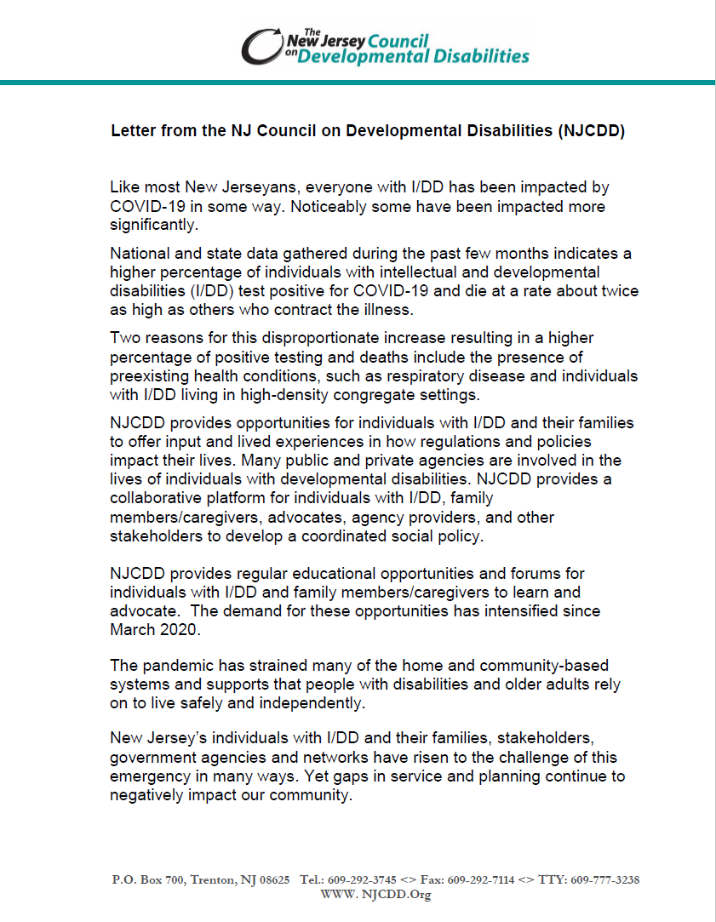
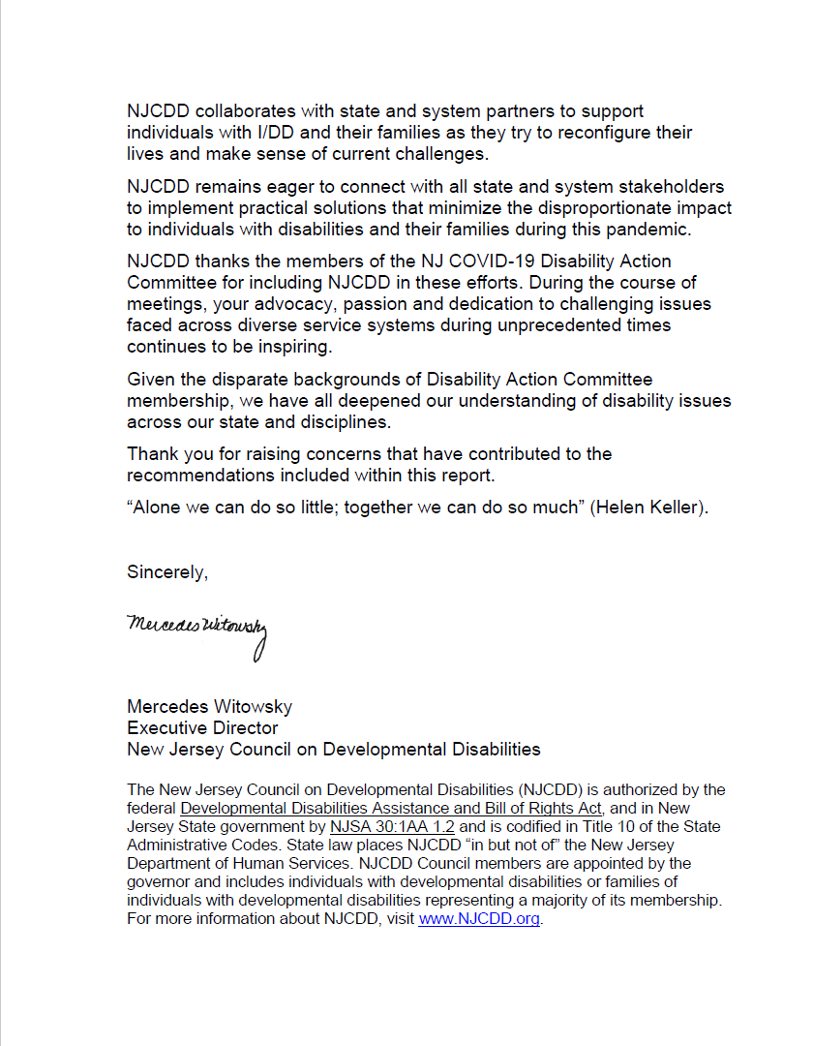

Letter from the NJ Statewide Independent Living Council

The New Jersey Statewide Independent Living Council (NJSILC) strongly endorses the submission of this Interim Report. The Council is honored to have two representatives on this committee, and we welcome the opportunity to support this committee’s work by providing American Sign Language interpreters as needed.
The NJSILC is a federally mandated council whose members are appointed by the governor. NJSILC membership is composed of people with disabilities and organizations working with people with disabilities. The NJSILC writes and monitors the federally mandated State Plan for Independent Living (SPIL), and conducts annual public forums on issues concerning all people with disabilities.
Emergency management and preparedness has been a NJSILC priority since 1999. The Council has worked with emergency management professionals for more than 20 years to provide critical, disability-specific input on statewide planning and preparedness procedures. It also works closely with New Jersey’s 11 Centers for Independent Living Centers (CILs) to educate people with disabilities on how to be better prepared for emergencies and disasters.
Thus, the Council is deeply concerned that New Jersey’s response to COVID-19 did not adequately anticipate the needs of people with disabilities. Writing letters to remind government officials that people with disabilities have the civil right to life-saving critical care during emergencies and disasters has been truly frustrating. It is also exhausting and equally disheartening to have to continually remind elected and appointed officials that most people with disabilities live independently in the community that that they are being severely isolated due to the significant constriction of available community based support services because of the lack of PPE and low wages paid to individuals who perform this essential work. Additionally, the well documented COVID-19 incidence, prevalence and mortality rates in the state’s long-term care facilities (LTCs) is horrifyingly unacceptable. It is more horrifying to know that the Section 1135 emergency waiver granted to the state for this emergency has made it easier to send more people with disabilities to these virus-infected facilities simply because access to accessible sheltering/housing and community-based supports are unavailable.
The NJSILC strongly believes that New Jersey has the wherewithal and willingness to do better for its people with disabilities before, during and after emergencies and disasters. New Jersey must do this not only as a matter of law but, also, because it is the right thing to do.
NJSILC endorses this submission of this Interim Report with the aforementioned thoughts in mind.

Sincerely,
X His Mark
Norman A. Smith, Chair NJ Statewide Independent Living Council

A Letter from a Parent Perspective
Dear NJ COVID-19 Disability Action Committee,
As a parent of a 38-year-old daughter with profound intellectual and developmental disabilities (IDD), I have an unenviable role of giving voice to her needs and wants. My daughter does not use words to communicate and yet speaks volumes with her demeanor. She is completely dependent on others for all of her basic care needs and still defies public perception by living in her own apartment, which is a self-directed residential option in the state of New Jersey. We were one of the first families in the state to embrace this national model for people with IDD at a time when the state was struggling to identify individuals willing to pilot this concept. Self-directed service options are more cost-effective as compared to group homes and state institutions for people with IDD, and it provides more choice and control over quality of life indicators. Although, New Jersey has encouraged self-directed service options for people with IDD for more than two decades, sadly this population was overlooked in the state’s response to COVID-19. Leaving my daughter and many others in similar situations unsupported in the midst of peril.

The revolving door of public administration does not allow much time for transformational change on a systemic level. Therefore, it is incumbent upon negatively impacted communities to rise-up and shed light on practices that cannot be ignored. COVID-19 serves as this impetus for immediate advocacy by exposing the disability community to greater risk than the general public, and if left unaddressed it further oppresses a marginalized population. This is why, I would like to thank the NJ COVID-19 Disability Action Committee for its rapid response in creating space for distinct narratives from the disability community. It is with a debt of gratitude that I recognize the explicit value of this diverse group, its ability to incorporate different perspectives, and find commonalities to produce a Report of proactive measures. The Report represents the collective strength, range of knowledge, and experiences of the disability community, which better positions New Jersey’s leadership for addressing the needs of the persons with disabilities.

Sincerely Grateful,

Lorraine D’Sylva-Lee, Aaliya’s Mom

Letter from Sherlock Washington
For the past twenty years, I have been involved with various committees working on issues and challenges that individuals with disabilities face concerning employment. The COVID-19 pandemic has created additional difficulties that greatly effect this population, and as a blind entrepreneur, I have significantly experienced these problems first-hand through the struggles of my own business.

Last May, when a committee of disability groups, agencies, and individuals was formed to brainstorm ideas to solve some of the issues effecting people with disabilities and self-employment, I was compelled to participate. This committee was only a beginning for finding solutions for the countless disabled who are self-employed. We have been severely impacted by the pandemic, and in desperate need of support services and knowledge to help run our businesses successfully. After becoming aware of the many crucial issues the disability community needs to overcome, it is my hope that a statewide board will soon be created to address the challenges we face now and in the future as disabled business owners.

I would like to thank all those involved with the committee for their time, dedication, and hard work. I truly believe that working together we can make a difference in the quality of life for people with disabilities.

Letter from the Ombudsman for Individuals with Intellectual or Developmental Disabilities and Their Families
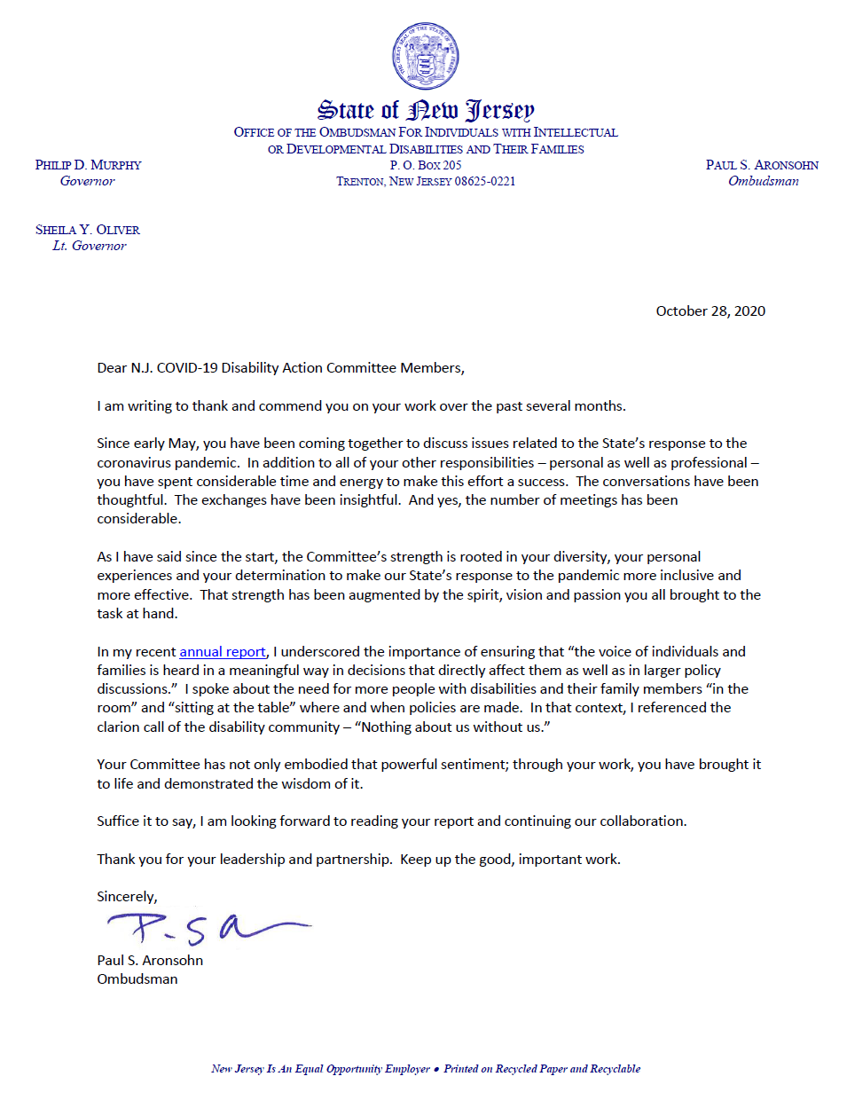

Directory
Javier Robles, J.D. (Organizer)

Javier Robles has a Juris Doctor from Seton Hall Law School and is an undergraduate of Rutgers University. He is the Director of the Center for Disability Sports, Health and Wellness at Rutgers University Department of Kinesiology and Health and a Professor at the University. He is the Organizer of the New Jersey Disabilities COVID-19 Action Committee and Vice President of the Latino Action Network of New Jersey; he is also a board member of the Northeast Region Board of Canine Companions for Independence. Until 2010, he served as the Deputy Director of the NJ Division of Disability Services (DDS), situated in the New Jersey Department of Human Services. He was a member of the Governor’s Blue-Ribbon Panel on immigration a past Chairperson of the Drug and Alcohol Advisory Council for the Deaf, Hard of Hearing, and Disabled, a past member of the Governor’s Working Group on Latino Issues, and he served on the NJIT’s EmployMe! and Business Advisory Council. He was an organizer for both New Jersey’s first Latino Health Conference and the Latinos with Disabilities Employment Conference and was the planning group’s Chairperson for the Governor’s Conference on Employment of People with Disabilities and for the African Americans with Disabilities Employment Conference.

In addition to his vast experience, Robles has received numerous awards and recognitions, including the Minorities with Disabilities Advocacy Award, the Seton Hall University Ramón Ramos Medal of Courage, the Comité Noviembre Award, the Rutgers University President of the Year Award, the Project Freedom’s Angel Award, and as the northeast Ambassador for Canine Companions for Independence. He has been published in Seleciones, New Mobility, Disability.gov, Survival After SCI, and ThisAbled.com, and has been featured in the Star Ledger, Home News Tribune, and on Despierta America, The Roccio Show, Images/Imagines, Sally Jesse Raphael, and We the People.

Robles and his wife have two children and live in New Jersey with their service dog Delbert.

{Image Description: Javier is looking at the camera with a slight smile. He is wearing a white and blue striped dress shirt and a grey striped tip. He has a mustache and goatee.}
javier.robles@rutgers.edu

Krystle Allen

Krystle Allen is a Newark, New Jersey native. She is a millennial entrepreneur and non-profiteer who is no stranger to work that involves community development, social change, and grassroots efforts. She is presently employed with the New Jersey Commission for the Blind and Visually Impaired under the Department of Human Services in the role of the community outreach specialist.

Simultaneously, Krystle serves as the founder and president of a growing non-profit organization in the city of Newark called Eyes Like Mine Inc. Eyes Like Mine Inc. has a mission to share awareness about the abilities and potential of individuals with vision loss through community service initiatives, comprehensive empowerment workshops, and innovative social change awareness events.

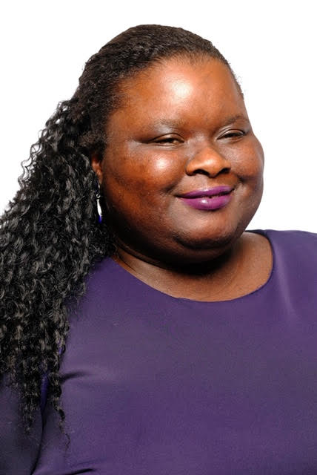
Krystle is a graduate of Newark’s University High School and continued her education by majoring in social science at Essex County College Newark, NJ campus. Currently, she is actively pursuing her enrollment in the Leadership Newark class of 2020 to strengthen her leadership abilities further. Lastly, Krystle has completed a community training program through the Greater Newark L.I.S.C. Despite her vision loss, Krystle has a vision gained to impact one community at a time through her combined advocacy activities.

{Image Description: Krystle is smiling at the camera in a purple top with purple lipstick and long, black curly hair.}

Kelly Boyd

Kelly Boyd is an Access & Functional Needs Planner for the NJ Office of Emergency Management and serves as a Co-Chair of the NJ Group for Access and Integration Needs in Emergencies & Disasters (NJGAINED). Previously, she served as the AmeriCorps Program Officer for the New Jersey Commission on National & Community Service and the Disaster & Disability Services Coordinator for the NJ Governor’s Office on Volunteerism.

{Image Description: The picture shows a white adult female who has long, straight blonde hair. She is smiling and has blue eyes. She is wearing a black suit and a diamond necklace.}

Donald Campbell

Donald Campbell is a lifelong resident of Atlantic County, growing up in Egg Harbor Township and attending Egg Harbor Township High School. He graduated from Atlantic Cape Community College and Stockton University with his bachelor’s degree in Political Science. Donald went on to Widener University Delaware Law School and has his JD. Donald is currently the director of the Atlantic Center for Independent Living.

Donald has cerebral palsy, a congenital disorder of movement, muscle tone, or posture. His personal experience of living with a disability, his robust humor and positive outlook make him a perfect fit to lead this new Center in its inaugural journey. He is excited at the prospect of being able to combine his knowledge of special education and disability law with his passion to advocate along with others who live with disabilities.

{Image Description: Donald is sitting behind his desk engaged in conversation while wearing a plaid button down underneath a a blue and black knit cardigan with buttons}

Casey Coyle

Casey Coyle is a certified occupational therapy assistant who has practiced in a diverse variety of settings, including schools, long-term care facilities, and nonprofit organizations serving adults with developmental and intellectual disabilities. She feels privileged to be in a profession that empowers individuals with disabilities of all ages with the independence and self-determination necessary to experience life with meaning, fulfillment, and joy!

{Image description: Casey is smiling at the camera in a black top. She has dark shoulder length hair with side swept bangs.}

Lorraine D’Sylva-Lee

Lorraine D’Sylva-Lee is a Senior Training Consultation Specialist for Rutgers University Behavioral Health Care, Children’s System of Care, Training and Technical Assistance Unit and the Chief Executive Officer for LEE Services, a provider agency for people with intellectual and developmental disabilities. She is a dynamic, highly motivated, and exceptionally hard working professional with more than 30 years of promoting excellence in the quality of support options for people with intellectual and developmental disabilities and their families. Ms. D’Sylva-Lee has an extensive history of providing national and statewide training and technical assistance for innovative person-centered approaches that cultivate positive relationships and promote policies that focus on improving quality of life outcomes for people with disabilities and their families. Her passion, dedication, and unwavering commitment for this vocation is driven by the resilient spirit of her daughter with profound intellectual and developmental disabilities, who struggles each day to overcome the societal stigma of lowered expectations.

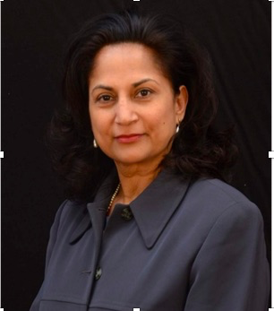

{Image Description: Lorraine is looking directly at the camera with determination, she has thick, black shoulder length hair and is wearing a blue-grey button down top, silver earrings, and red lipstick.}

Lydia Fecteau

Lydia Fecteay completed her MA in 1996 and began working as an adjunct Professor at Richard Stockton College. She specializes in writing and literature courses. She even developed her own courses including Disability and Literature, Science Fiction as Literature, Disability History and Culture, and History of Comic Books. In 2016, she completed co-developing a Disability Studies Minor at Stockton University. She also teaches English and literature at Atlantic Cape Community College. She was promoted at ACCC to Senior Adjunct, and fellow Stockton professor nominated her Distinguished Adjunct.
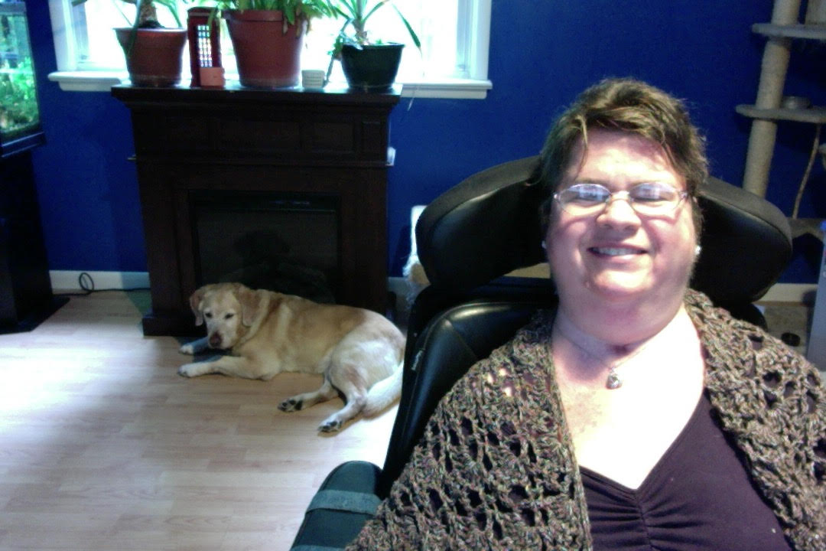

{Image Description: Lydia is sitting, smiling, in her motorized wheelchair. She has short brown hair, glasses, a silver necklace, a purple top, and crocheted light brown shawl. In the background is her yellow lab and house plants in a bright purple room with lots of natural light}

Sam Friedman

Sam Friedman is President of VOR (“a Voice of Reason”), the premier
national organization advocating for the full range of quality residential
options and services for people with intellectual and developmental
disabilities; Chair of the NJ Developmental Centers Families&#39; COVID-19 Alliance; and Vice-President of the Green Brook Regional Center Family and Friends Association. He co-led the 2012-13 effort to oppose then Gov. Christie’s move to close NJ’s two northernmost Developmental Centers (DCs), and spearheaded, early on in the COVID-19 pandemic, the successful DCs’ families’ and guardians’ effort to have the State systematically and repeatedly test all residents and staff for SARS-CoV-2. He is retired from a quarter-century career in public health in New York City. He is co-guardian of his sister, who is a life-long resident of
Intermediate Care Facilities for Individuals with Intellectual Disabilities.
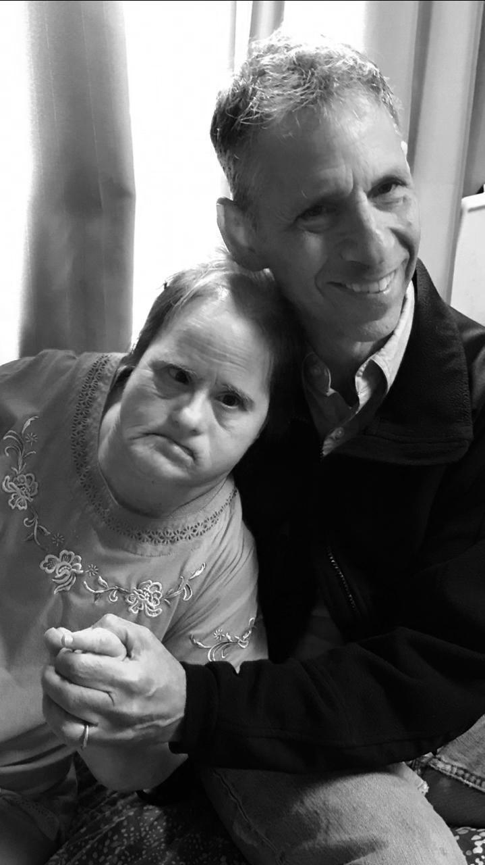

{Image Description: Sam, a smiling, short-haired, older man wearing a dark jacket and jeans, holding the hand of his sister – leaning on him – wearing a light, embroidered shirt.}

Millie Gonzalez, M.A.

Milagros “Millie” Gonzalez, M.A., is co-founder of the New Jersey Disability Collective; board president for The Partnership for Inclusive Disaster Strategies; board chair, retreat organizer and program developer for the Spina Bifida Resource Network (SBRN); and vice board chair for the Alliance Center for Independence (ACI), host of the annual NJ Disability Pride Parade & Celebration. Millie is a communication strategist, writer, editor and event planner with nearly 20 years of experience. A certified peer mentor with United Spinal Association and member of the ADA Trainer Leadership Network, she is a disability consultant, trainer and speaker. Named Ms. Wheelchair New Jersey 2019 with her platform, #LiveFiercely through Self-Care, including health, mental wellness and civic engagement, Millie is one of only 30 honorees of Diversability's national D-30 Disability Impact List.
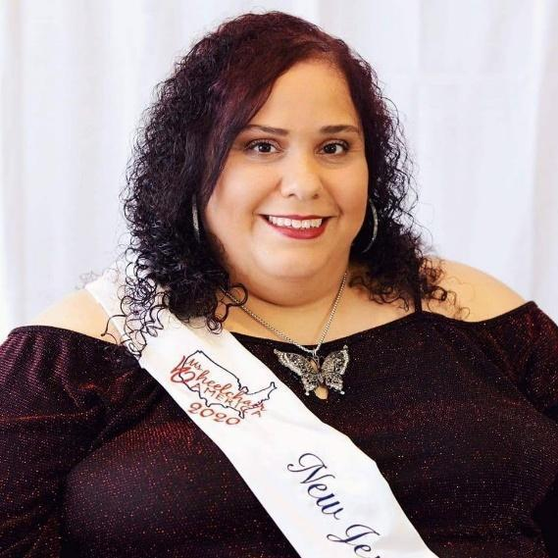
{Image Description: Millie Gonzalez, a plus-sized, Hispanic, disabled female with dark chocolate cherry curly hair, wearing makeup, a large silver and black butterfly necklace, a dark red, glittery, cold-shoulder top and a white sash with red and white letters that says Ms. Wheelchair America 2020-New Jersey, smiles at the camera.}

Linda Newman

Linda is the mom to 2 young adult men. Max, 27 has Autism and a mental health diagnosis. He is the driving force for her advocacy and Program development and volunteerism in the South Jersey Community. For over 10 years Linda and her husband Eric have been running a Special Needs Basketball program through the Katz JCC supported by NIKE Corp. and many community volunteers. She coordinates monthly community outings Through JFCS and serves on various councils and committees to improve the lives of People with Disabilities. Professionally, Linda works for Novartis Pharmaceuticals.
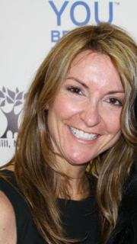

{Image Description: Linda is smiling at the camera while at an event. She has long brown and highlighted hair and is wearing a black dress.}

Colleen Roche

Colleen Roche, a Certified Community Resource Specialist, is an accomplished regional training coordinator, program developer, and a subject-matter expert on disability health and wellness. For nearly two decades, her work has centered on raising awareness of disability rights and increasing access to domestic violence and abuse-related services for the disabled. Certified by the New Jersey Victim Assistance Academy, she is well versed in essential public health services, New Jersey Practice Standards, and the culture of local public health in NJ. She is an experienced disability consultant who regularly develops and delivers trainings and presentations for individuals with disabilities, healthcare providers and other allied professionals on a variety of topics. A disabled activist and organizer, Colleen is the co-founder of the New Jersey Disability Collective, board chair for the Alliance Center for Independence, treasurer for the New Jersey Statewide Independent Living Council and vice chair of the New Jersey Personal Assistance Services Advisory Council.

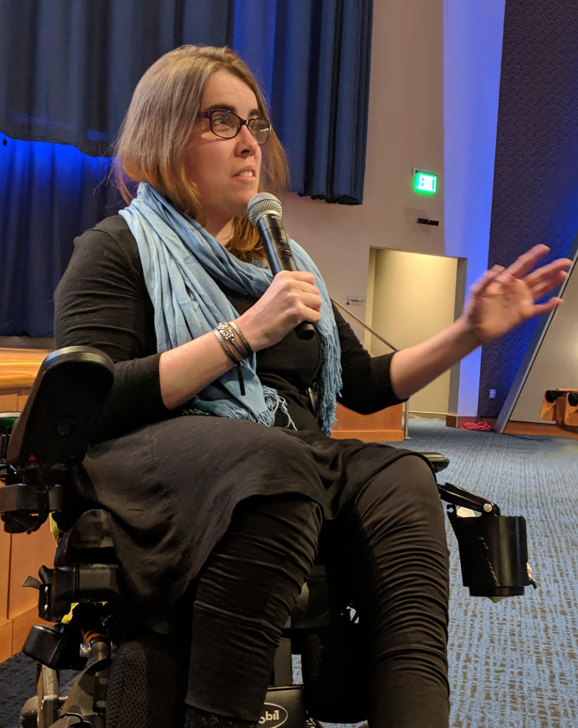

{Image Description: Colleen Roche is a white, disabled female with light brown hair wearing glasses, black pants, a long black shirt and light blue scarf, who is sitting in a powerchair and speaking into a microphone in her right hand and gesturing with her outstretched left arm.}

Arlene Romoff

Arlene Romoff is a late-deafened adult and bilateral cochlear implant user. She is a hearing loss advocate and author of two books on cochlear implants, as well as many articles. She is co-founder and past president of the Hearing Loss Assn of NJ, and has served for many years as a governor-appointed member of the NJ Division of the Deaf and Hard of Hearing Advisory Council, as well as other organizational boards. Her numerous awards include the Humanitarian Award from Theatre Resources Unlimited, an organization of NYC theater producers, for her innovative work bringing open captioning to live theater performances. Her advocacy work was also recognized by a NJ Joint Legislative Resolution. Considered an expert, she is consulted and speaks on topics including cochlear implants, assistive technology, accessibility, and advocacy.

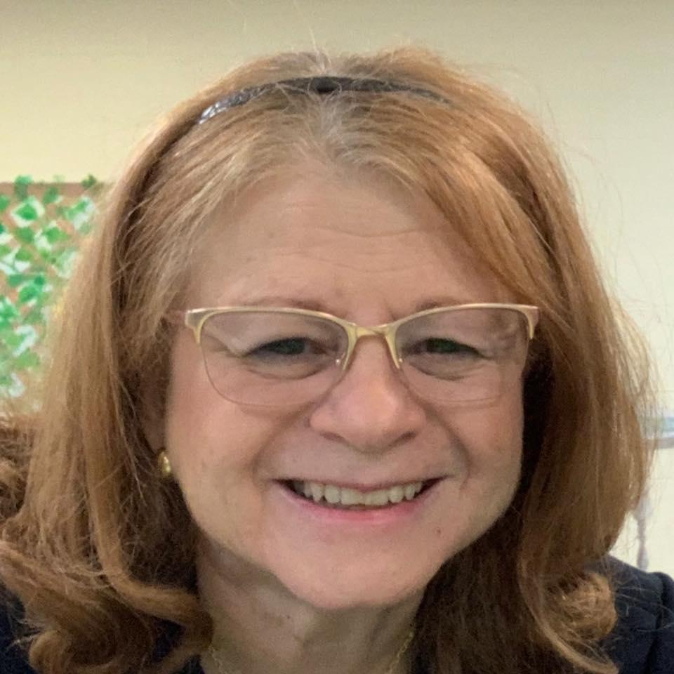

{Image Description: Arlene Romoff is a smiling gregarious-looking woman, with reddish shoulder-length hair pulled back with a headband. She wears gold-rimmed glasses and a navy blue jacket.}

Norman Smith, HCCCP

Norman A. Smith is the co-founder and Associate Executive Director of Project Freedom Inc. He has been involved with the creation of over 500 apartments designed to be accessible for people with disabilities in five counties in New Jersey representing over $100 million in assets. In addition, in 2020, Smith started his sixth nonconsecutive two-year term as Chair of the NJ Statewide Independent Living Council, a federally mandated body appointed by the governor that plans independent living services in the state. As an advocate, Smith has worked with elected officials from both parties to create programs and supports for people with disabilities. Smith is recognized in New Jersey as a Subject Matter Expert
on inclusive emergency management and preparedness for people with disabilities and has earned certificates from the Emergency Management Institute. He is a founding member of the Special Needs Advisory Panel for NJOEM that has evolved into the Group for Access and Integration in Emergencies and Disasters (GAINED).

{Image Description: Norman A. Smith, looking up at the camera smiling, is dressed in a green shirt and cap with CERT written on both. He is a white male wearing glasses with a blue lanyard around his neck.}

Carole Tonks

Carole Tonks has over 25 years’ experience in the disability community. She has served for the past 13 years as the Executive Director for the Alliance Center for Independence (ACI) in Edison, New Jersey. ACI is a center for independent living serving disabled individuals and their families in Middlesex, Somerset, and Union counties. Carole has been involved in emergency preparedness efforts for the past 10+ years.

Prior to ACI, Carole worked for 13 years at the NJ Council on Developmental Disabilities, where she was the coordinator of their statewide advocacy project.

Carole became involved in disability rights after her son was born with autism. She lives in Howell, NJ with her husband Jerry and their son Jason.

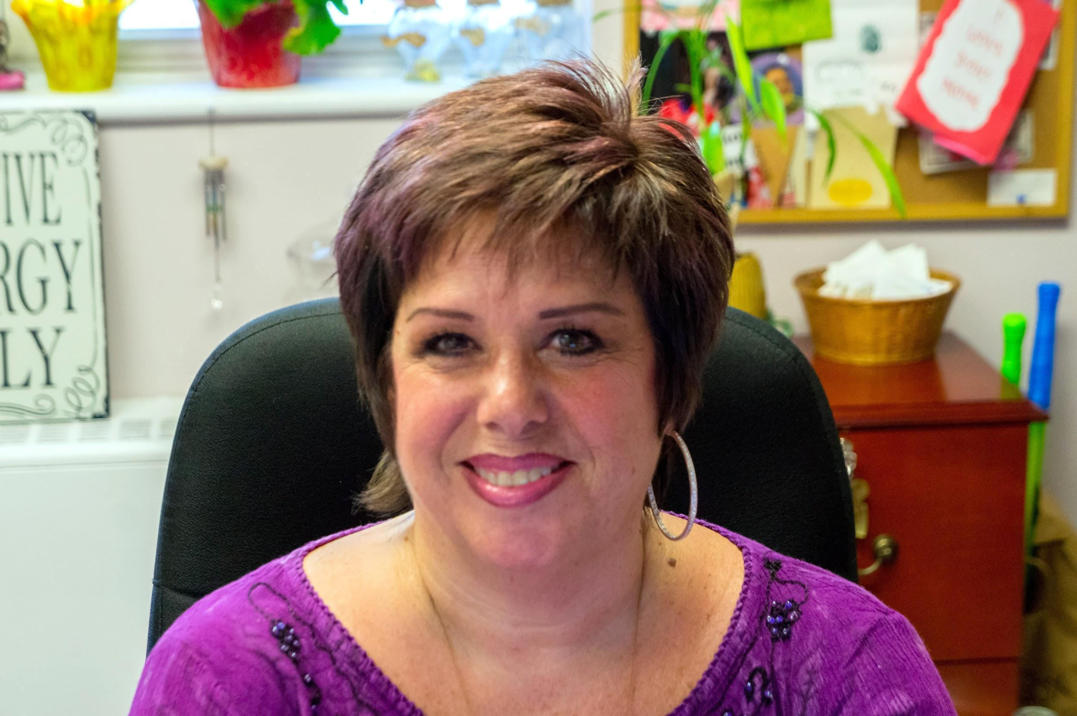
{Image description: Carole is smiling at the camera while seated in an office while wearing a purple shirt, pink lipstick, and hoop earrings.}

Sherlock Washington

Sherlock Washington is a 55-year-old entrepreneur who is blind due to Retinitis Pigmentosa, a degenerative eye condition first detected when he was 7 years old. A sports devotee most of his life, Sherlock is well known for his athleticism in the visually impaired community. He is a co-founder Blind Athletes – New Jersey for many years and currently serves as a board member. Having made the U.S. Paralympic Team in 1990, he journeyed to the Netherlands where he won the bronze (3rd place) medal in the high jump. Sherlock also played goal ball from 1986-1995and his team received the gold (1st place) medal in the 1993 national competition. Sherlock is the holder of 2 Beep Baseball World Series championship rings earned as a member of The West Coast Dawgs. In 2001 he made the offensive all-star team. He has played for other states for several years and each he has played on has had top ranking but in 2009, he co-founded New Jersey’s first beep baseball team for blind athletes, the NJ Lightning.

He is a mentor for the EDGE program for adolescents who are blind or visually impaired and serves as a board member for NJCRID-New Jersey Commission for Recreation for individuals with disabilities. He also served as a Governor’s appointee to the NJ Commission for the Blind and Visually Impaired’s State Rehabilitation Council for several years. An active motivational speaker, Sherlock voluntarily addresses students and other groups to dispel stereotypes and promote awareness of the capabilities of people who are blind.

Sherlock established SW Unlimited LLC in 1998 and 10 years later was honored by the Granville Academy as the recipient of their 2008 award for Entrepreneurship. The primary focus of SW Unlimited is working with Fortune 500/1000 companies, state and federal government in buying and selling new and used computer equipment, as well as adaptive technologies. In 2007, SW Unlimited LLC partnered with Freedom Scientific/Vispero and HIMS Inc. And became a regional distributor of low vision and blindness products as well as products to individuals with learning disabilities. SW Unlimited LLC also works to minimize the adverse impact on the environment by coordinating the appropriate disposal of used computer equipment.
Sherlock, who is a graduate of Rider University with a degree in Computer Science lives in Matawan, NJ, with his wife Kim and son, Edward.

{Image Description: Sherlock, a Black male, is seated in his office wearing a light grey suit and light-colored button-down shirt. He is looking at the camera with a slight smile on his face.}

Caitlin R. Williams

Caitlin R. Williams is a researcher and PhD candidate in the Department of Maternal & Child Health at the Gillings School of Global Public Health at the University of North Carolina at Chapel Hill. Caitlin has served as a member of the American Journal of Public Health’s 2019 Student Think Tank, the CDC’s National Preconception Health and Health Care Initiative Consumer Workgroup, and the Advisory Committee to the National Maternal and Child Health Workforce Development Center. Caitlin is also the host of #CoronaChat, a bilingual video series that provides updates on the best available science on COVID-19 in a calm, non-partisan format. Born in Hoboken, NJ, Caitlin was raised and educated in the Maplewood-South Orange community.

{Image description: Caitlin R. Williams is looking into the camera smiling. A mixed-race, Korean/Welsh/French-Canadian woman, she has long dark hair with bangs and is wearing a black sleeveless dress}

Mercedes Witowsky

Mercedes Witowsky is the Executive Director at The New Jersey Council on Developmental Disabilities (NJCDD). Prior to her role at the Council, she has held direct support and administrative positions supporting individuals with disabilities for almost 40 years. Equality, citizenship, choice and control for people with disabilities are at the core of her personal values and beliefs, with the ultimate goal to help establish a more reliable and sustainable service delivery system for all New Jersey citizens with I/DD and their families. Mercedes is mom to Anthony and Tina, a young woman who lives at home with disabilities resulting from a stroke at age 16.

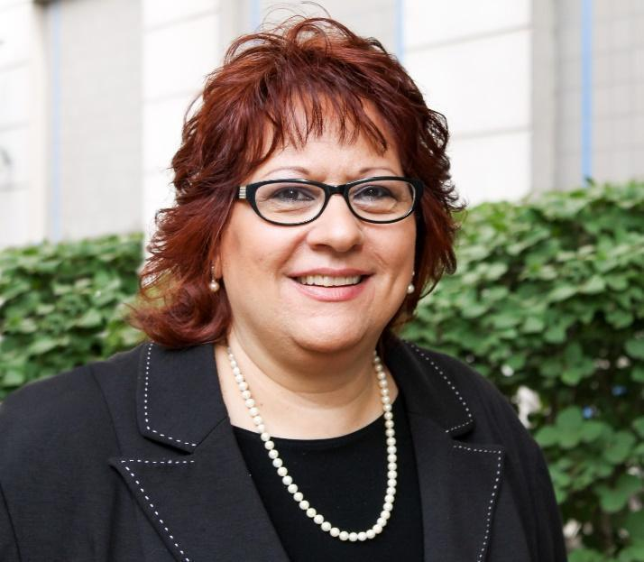

{Image Description: Mercedes is photographed sharing a welcoming smile in an outdoor green courtyard, has deep cherry short shoulder length hair and wears black framed glasses to match her white piped black blazer and pearls.}

Linda Zani Thomas

Linda Zani Thomas is a parent advocate and activist for quality care of medically fragile adults with developmental disabilities. She is one of the founding mothers of the Red Ribbon Academy medical special needs day program, a co-creator of the Quality of Life Experience study, and the original leader of the Multiply Disabled division of Parents of Blind Children, NFBNJ.

Linda is known as “Professor Z” to her students at Montclair State University, where she creates curricula and teaches classes, including Crisis Communications and Organizational and Group Leadership.
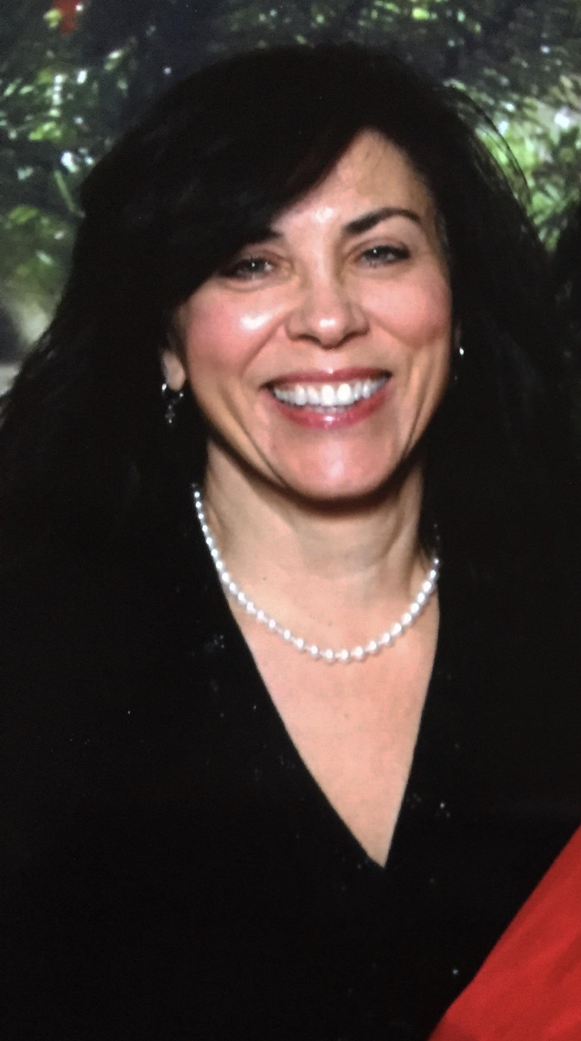

{Image description: Linda is smiling at the camera while wearing a black top and pearls. She has dark shoulder length hair.}

Rose Greenblatt (Facilitator)

Rose Greenblatt is a proud alumna of Rutgers University School of Environmental and Biological Sciences. She is currently a graduate student at Washington University in St. Louis, working towards her clinical doctorate in occupational therapy. Previously she has worked as a Direct Support Professional and Support Coordinator through the Department of Developmental Disabilities and has assisted Javier in teaching his course, “Movement Experiences for Individuals with Disabilities”.

Rose is currently serving as the DAC’s facilitator and administrator. Please feel free to reach out with any comments or questions.
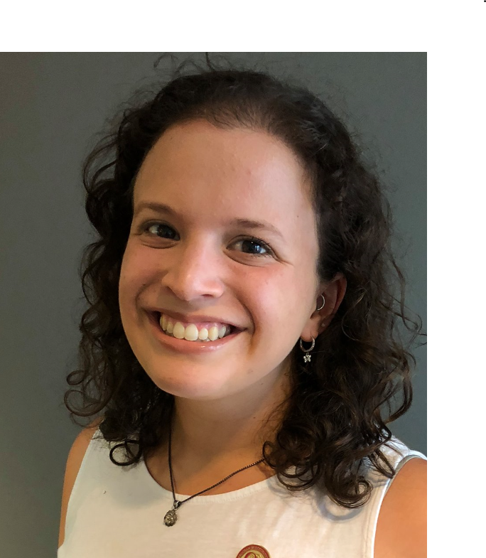
{Image Description: Rose, a smiling 25-year old woman with curly shoulder length brown hair wearing a white top with a small silver flower necklace and her occupational therapy pin}

Please contact us at NJDisabilityActionCommittee@gmail.com

In Collaboration With…

Paul Aronsohn
NJ State Ombudsman for Individuals with Intellectual or Developmental Disabilities and Their Families

Christine Bakter
Associate Director, Office of the Ombudsman for Individuals with Intellectual or Developmental Disabilities and Their Families

Debbie Hehir
ADA Coordinator, Middlesex County Office of Aging & Disabled Services

A special thank you to Cassandra Yushchak, a Junior at Rutgers University, who joined to help us complete the final stages of this report.

Works Cited
“CDC Works 24/7.” Centers for Disease Control and Prevention, 28 Mar. 2018.
Center for Systems Science and Engineering at Johns Hopkins University. “COVID-19 Dashboard.” Johns Hopkins University Coronavirus Resource Center, 2020. https://coronavirus.jhu.edu/map.html.
Centers for Disease Control and Prevention (CDC). “COVID-19 Guidance for Shared or Congregate Housing.” Coronavirus Disease 2019 (COVID-19), 2020.
Centers for Disease Control and Prevention (CDC). “People with Disabilities.” Coronavirus Disease 2019 (COVID-19), 2020. https://www.cdc.gov/coronavirus/2019-ncov/need-extra-precautions/people-with-disabilities.html.
Centers for Disease Control and Prevention (CDC). “Symptoms of Coronavirus.” Coronavirus Disease 2019 (COVID-19), 2020. https://www.cdc.gov/coronavirus/2019-ncov/symptoms-testing/symptoms.html.
“Department of Human Services | Disability Employment.” Department of Human Services, www.nj.gov/humanservices/disabilityemployment.html.
“Disability and Health U.S. State Profile Data: Adults | CDC.” Centers for Disease Control and Prevention, 20 Nov. 2019 www.cdc.gov/ncbddd/disabilityandhealth/impacts.
Division, Digital Communications. “What Is Section 504 and How Does It Relate to Section 508?” HHS.Gov, 19 Aug. 2015, www.hhs.gov/web/section-508/what-is-section-504/index.html.
“Feds Launch Investigation into NJ Veterans Homes Where 192 Have Died during COVID Pandemic.” NorthJersey.Com, 28 Oct. 2020.
Gander, Kashmira. “People with Intellectual and Developmental Disabilities More Likely to Die from COVID-19, Study Suggests.” Newsweek, 29 May 2020, www.newsweek.com/intellectual-developmental-disability-coronavirus-1507271?fbclid=IwAR3AFiIDYsOOvKe2aUeeV3hpJtzfGsK7kjArF9OrjzWK-s2HlwXJ59iB4qM.
Greenhalgh, Trisha, Matthew Knight, Christine A’Court, Maria Buxton, and Laiba Husain. “Management of Post-Acute Covid-19 in Primary Care.” BMJ 370 (2020): m3026. https://doi.org/https://doi.org/10.1136/bmj.m3026.
“IHME | COVID-19 Projections.” Institute for Health Metrics and Evaluation
Hu, Ben. “Characteristics of SARS-CoV-2 and COVID-19.” Nature Reviews Microbiology, no. December (2019). https://doi.org/10.1038/s41579-020-00459-7
“Introduction to the ADA.” Introduction to the ADA, www.ada.gov/ada_intro.htm.
Ives-Rublee, Mia. “Twitter Thread | Covid19 and Post-Polio Syndrome,” 2020. https://twitter.com/SeeMiaRoll/status/1285393170679963648.
Jordan, Rachel E., Peymane Adab, and K K Cheng. “Covid-19: Risk Factors for Severe Disease and Death.” BMJ 368 (2020): m1198. https://doi.org/https://doi.org/10.1136/bmj.m1198.
Lokugamage, Amali U, Sharon Taylot, and Clare Rayner. “Patients’ Experiences of ‘Longcovid’ Are Missing from the NHS Narrative.” BMJ Opinion, 2020. https://blogs.bmj.com/bmj/2020/07/10/patients-experiences-of-longcovid-are-missing-from-the-nhs-narrative/.
Mahase, Elisabeth. “Covid-19: What Do We Know about ‘Long Covid’?” BMJ 370 (2020): m2815. https://doi.org/10.1136/bmj.m2815.
Rights, Office For Civil. “Section 1557 of the Patient Protection and Affordable Care Act.” HHS.Gov, 16 Sept. 2020, www.hhs.gov/civil-rights/for-individuals/section-1557/index.html.
Samuels, Jocelyn. “GUIDANCE AND RESOURCES FOR ELECTRONIC INFORMATION TECHNOLOGY: ENSURING EQUAL ACCESS TO ALL HEALTH SERVICES AND BENEFITS PROVIDED THROUGH ELECTRONIC MEANS.” U.S. Department of Health and Human Services, Office for Civil Rights, 21 Dec. 2016, www.hhs.gov/sites/default/files/ocr-guidance-electronic-information-technology.pdf.
Scott Fallon, North Jersey Media Group. “Feds Launch Investigation into NJ Veterans Homes Where 192 Have Died during COVID Pandemic.” NorthJersey.Com, 28 Oct. 2020.
“Section 504, Rehabilitation Act of 1973 | U.S. Department of Labor.” Section 504.
“State and Local Governments (Title II).” State and Local Governments, www.ada.gov/ada_title_II.htm.
Times, The New York. “Covid in the U.S.: Latest Map and Case Count.” Https://Www.Nytimes.Com/#publisher, 29 Oct. 2020, www.nytimes.com/interactive/2020/us/coronavirus-us-cases.html.
Turk, Margaret A., Scott D. Landes, Margaret K. Formica, and Kathetine D. Goss. “Intellectual and Developmental Disability and COVID-19 Case-Fatality Trends: TriNetX Analysis.” Disability and Health Journal 13, no. 3 (2020): 100942. https://doi.org/10.1016%2Fj.dhjo.2020.100942.
“What Is Section 504 and How Does It Relate to Section 508?” HHS.Gov, 19 Aug. 2015, www.hhs.gov/web/section-508/what-is-section-504/index.html.
World Health Organization (WHO). “Coronavirus,” 2020. https://www.who.int/health-topics/coronavirus#tab=tab_3.
World Health Organization (WHO). “Preventing and Managing COVID-19 across Long-Term Care Services: Policy Brief.” Geneva, 2020.

