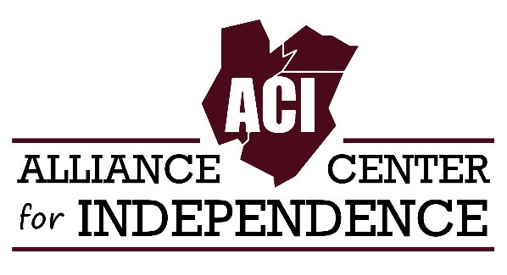
629 Amboy Ave, Edison, NJ 08837 ● adacil.org ● adacil@adacil.org
732-738-4388 ● Fax: 732-738-4416 ● TTY: 732-735-9644 ● VRS: 732-709-1023
FOR IMMEDIATE RELEASE CONTACT: Carole Tonks, Executive Director, Alliance
Center for Independence Phone: (732) 738-4388 / E-mail: ctonks@adacil.org
Website: www.adacil.org

THE 7th ANNUAL NEW JERSEY DISABILITY PRIDE PARADE & CELEBRATION SET FOR OCTOBER 7th IN TRENTON, NJ

More than 800 people with disabilities, supporters, friends and organizations representing a wide variety of services throughout NJ will converge on Mill Hill Park in downtown Trenton for the “Festival in the Park - 7th NJ Disability Pride Parade and Celebration.”

The free event is a grassroots effort organized and hosted by the Alliance Center for Independence (ACI). ACI is a 501(c)(3) Center for Independent Living, community-based, grassroots organization that supports and promotes independent living for people with disabilities in Middlesex, Union and Somerset counties.

"This is the one event in New Jersey that the disability community can get together and just have a day to celebrate pride in each other," says Carole Tonks, Executive Director of the Alliance Center for Independence, and chief organizer of the event.

The purpose of the NJ Disability Pride Parade is to celebrate pride within the disability community and to promote the belief that disability is a natural and beautiful part of human diversity.

The event will feature a number of disabled artists that will be taking the NJDPP stage for the first time. These include Broadway singer Ethel Barnes, recording artist and composer Nenad Bach, 14-year old song writer and rapper Sparsh Shah, Black Cat Habitat, an indie pop-rock band and Signs of Praise Ministry, a gospel group that sings through the use of sign language. Fan favorites including recording artist Lachi, folk singer Johnny Crescendo, Anomie Fatale, Miss Joy’s Exceptional Dance Team, and Kaleigh Brendle will be returning.

The day kicks off with an address by NJDPP 2017 Parade Marshal Ryan Roy, an advocate for the autism community on the steps of the Trenton War Memorial (1 Memorial Drive) This will be followed by a parade led by the Mercer County Special Services School District Drum Line to the site of the celebration on Mill Hill Park (Front Street and South Broad) There the Mayor of Trenton, the Honorable Eric Jackson, will give the official welcoming remarks.

Also addressing the crowd throughout the day will be Alice Hunnicutt, Director, NJ Division on Vocational Rehabilitation Services, Kevin Casey, Executive Director, NJ Council on Developmental Disabilities and Joseph Amoroso, Director of Division of Disability Services. Independent Candidate for Governor Seth Kaper-Dale will be addressing the crowd as well. Democratic candidate, Phil Murphy and Republican candidate, Kim Guadagno were invited to speak.

Adaptive Tai Chi classes, a bubble artist, photo booth, bouncy castle, stilt walker/performer, face painter and Sparkee from the Somerset Patriots will add to the festivities of the day. A wheelchair wash as well as food trucks will be available.

Attendees will also have an opportunity to learn about disability services and programs from 30 exhibitors representing organizations throughout the state, including the NJ Division on Disability Services, which will set up a health and wellness pavilion, offering cooking demonstrations and raffles.

The event relies solely on sponsorship, exhibitors, donations and in-kind services. Sponsors include, Brownstone Diner and Pancake Factory, PSEG, NJ Division on Disability Services, NJ Council on Developmental Disabilities, Fun Truck’n Mobility, Herrs, Drake Cakes, Pepsico, Frito Lay, Stop and Shop, Coca Cola, REDFIN, Real Estate Company, the NJ Association for Centers of Independent Living, Ester Seals Disability Services, Easter Seals, Freehold Buick and GMC, and the Statewide Advocacy Network (SPAN) to name a few.

For highlights of last year’s event, please click the link below.

NJDPP Highlights 2016

