For Immediate Release
Carole Tonks
Executive Director
732-738-4388
ctonks@adacil.org

Personal Assistance Services Program Now Offered at the Alliance Center for Independence

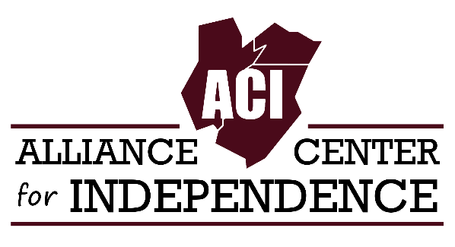
EDISON, NEW JERSEY - The Alliance Center for Independence (ACI) is very pleased to announce we are now administrating the State funded Personal Assistance Services Program (PASP) in Middlesex County. We thank the Middlesex County Office of Aging and Disabled Services for the award of the PASP grant.
ACI launched the administration of the PASP program in August and is enjoying the opportunity to work with the many consumers the program serves. Additionally, ACI plans to expand the program to include new participants.
“We were very happy to receive the PASP grant from Middlesex County,” remarks ACI Director Carole Tonks and she notes “The program fits our mission of supporting independent living for individuals with disabilities.”
PASP program staff are Sheri Nevis, the PASP Coordinator and Debbie Hehir, the PASP Consultant. Ms. Nevis comes to ACI after owning and operating a home care agency which provided services to individuals with a variety of disabilities and senior citizens. Ms. Nevis also has extensive education and experience in labor relations and human resources. Ms. Hehir retired from the Middlesex County Office of Aging and Disabled Services and has substantial knowledge and experience working with persons with disabilities and senior citizens, as well as previously administering the Middlesex County PASP program.
“As the new Coordinator for the Middlesex County PASP Program, I am very excited to be working on this vital and important program. I am also looking forward to increasing our consumer base” says Sheri Nevis, PASP Coordinator.
PASP provides personal care assistance services to self-directing adults with permanent physical disabilities who are engaged in employment or volunteer work or attending college. These personal care services are geared to support independent living. PASP participants direct the care they receive and are able to hire the workers they choose. Assistants perform a wide variety of tasks as assigned by the consumer and can include personal care, light housekeeping, food shopping and meal preparation. PASP consumers receive a weekly allotment of hours based on their needs ranging from 5 to 40 hours weekly.
Our diverse consumer base includes professors, staff working in education, retail, office and medical settings, as well as individuals active in a variety of volunteer positions.
PASP Consumer Kim Miller declares, “PASP assisted me at a critical time in my sight loss in order for me to continue my education. I absolutely could not imagine where I would be and how I would get by without the PASP program.”
Explains PASP Consumer Sara Boghdan, “PASP provided me help when I needed it most. I am employed part-time, I am able to be a contributing member of society. That would not be possible if not for PASP.”
Eligible participants must be self-directing, have a permanent physical disability, need assistance with activities of daily living, reside in Middlesex County, and be employed, volunteering or attending college or a vocational training program. Please note, eligible participants must not be receiving or eligible for Medicaid services. ACI PASP program staff are happy to field questions about the program and screen and assist applicants.
Are you or is there someone you know who needs some support to live as fully and actively as desired in the community? If so, please contact our office at 732-738-4388 or send an email to snevis@adacil.org.

