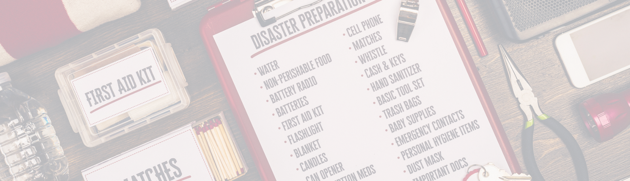
Pathways to Preparedness

July 24, 2023 10:00am - 12:30pm
Alliance Center for Independence
629 Amboy Avenue
Edison, NJ 08837

RSVP by July 17 to Argenys Caba 732.738.4388 acaba@adacil.org

Each individual must take responsibility for their own personal and family preparedness. Individuals have varying needs, abilities and resources and there is no one-size-fits-all disaster plan. Each person needs to evaluate their own unique needs, learn about and choose options available to them in their community, and prepare to the greatest extent possible prior to a possible disaster.
Most decisions on how to prepare for and respond to disasters are made at the local level. Each individual and family must understand how their county’s emergency management plan works, including how steps are taken to address the needs for people with disabilities in the area.
New Jersey Pathways to Preparedness provides the individual with a basic introduction to disaster planning. Disaster planning is a concept that utilizes strategies that are common to all types of public emergencies and disasters. This workshop encourages each person to consider an all-hazard approach, meaning that you create a plan one time, and then they can apply the plan to all types of hazards.

Participants of the training will receive all necessary training material as well as other items to assist them with their disaster preparedness efforts To schedule a training session, email EOCESF6@njsp.gov or call (609) 631-4363 